**Built a Lakehouse-style Analytics Pipeline on Azure (Olympics Mini-Warehouse)**

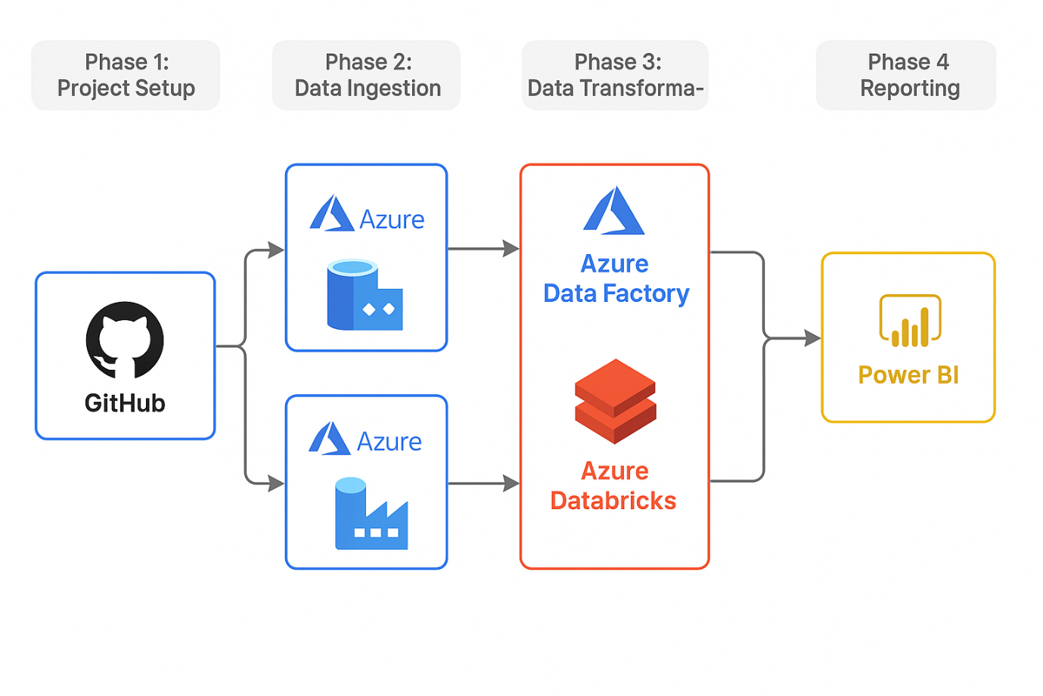

**Objective**

This project was a comprehensive, end-to-end data engineering assignment designed to test my skills in creating a full data pipeline using Azure services. I worked with four datasets from the Olympic Games.

My primary goal was to build a robust data pipeline that ingested, transformed, and prepared the provided

**Dataset (download by double click)**



**Phase 1: Project Setup & Data Ingestion**

1. **GitHub Repository**

* Created a new public GitHub repository for the project.
* Uploaded the four provided datasets (teams.csv, medals.csv, coaches.csv, and athletes.csv) to the repository.
* Committed all changes and added a clear README.md file that briefly described the project.

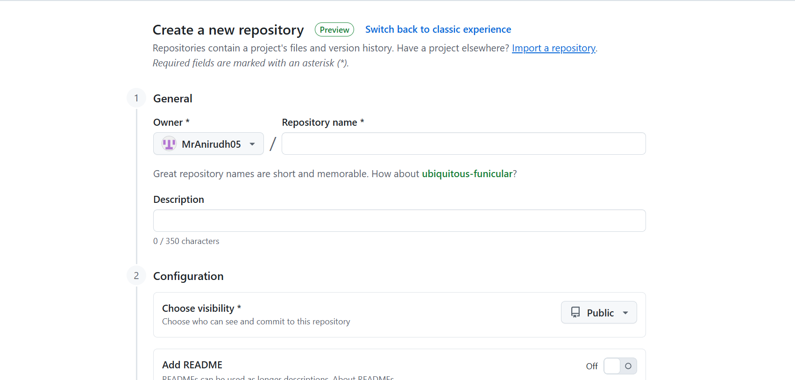

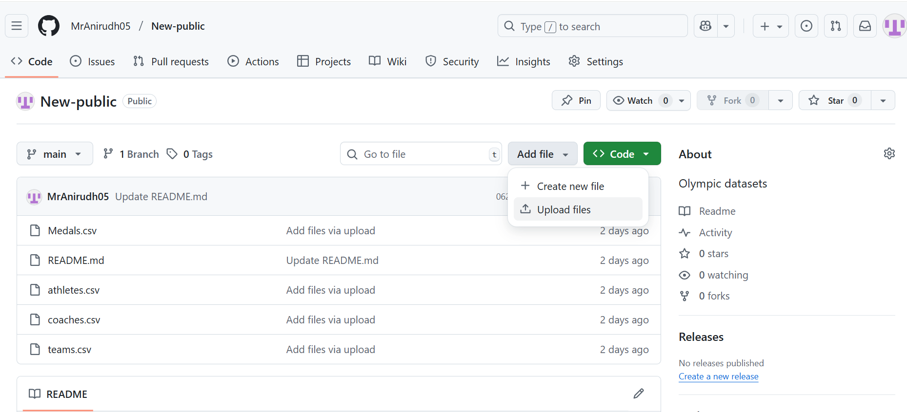

**2. Azure Storage**

* Created an Azure Storage Account with Data Lake Storage Gen2 enabled.
* Inside the storage account, created a file system named olympic-data.
* Within this file system, set up the following folder structure to represent the data layers:
  + **bronze/ (for raw, untransformed data)**
  + **silver/ (for cleaned and standardized data)**
  + **gold/ (for aggregated and ready-to-report data)**

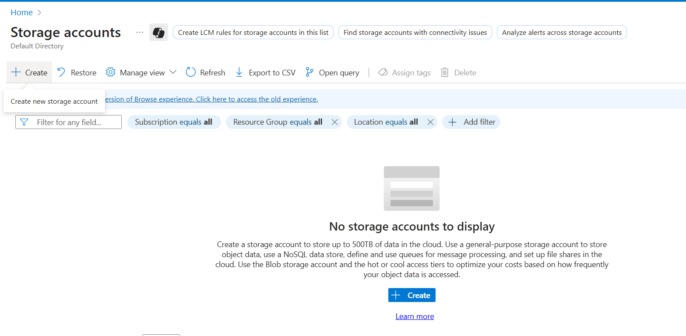

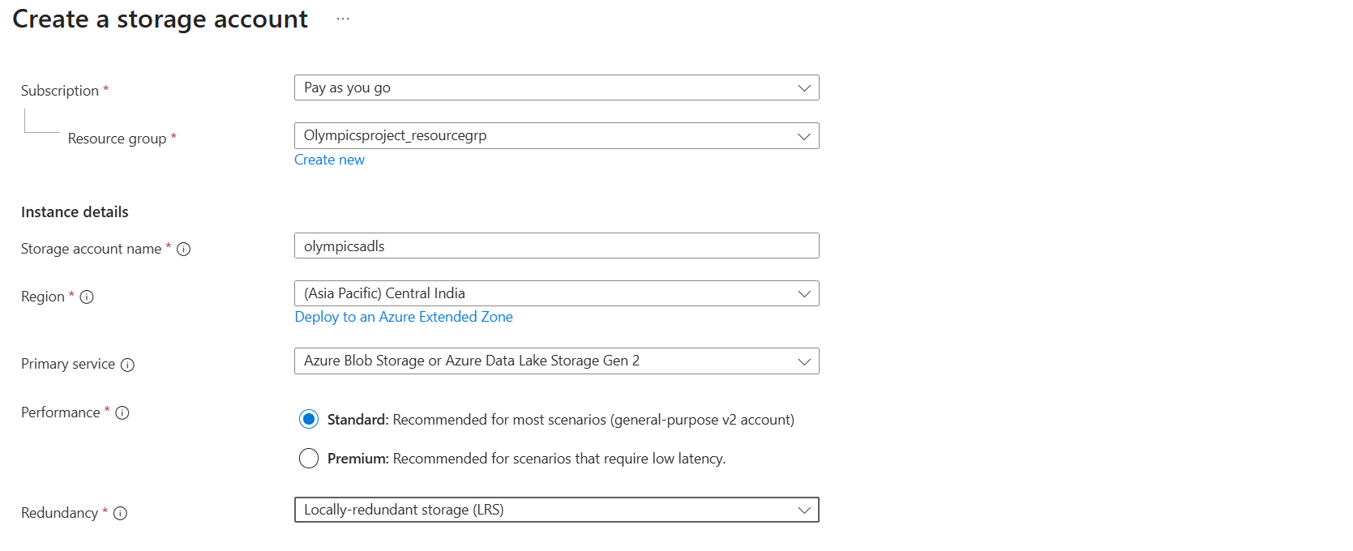

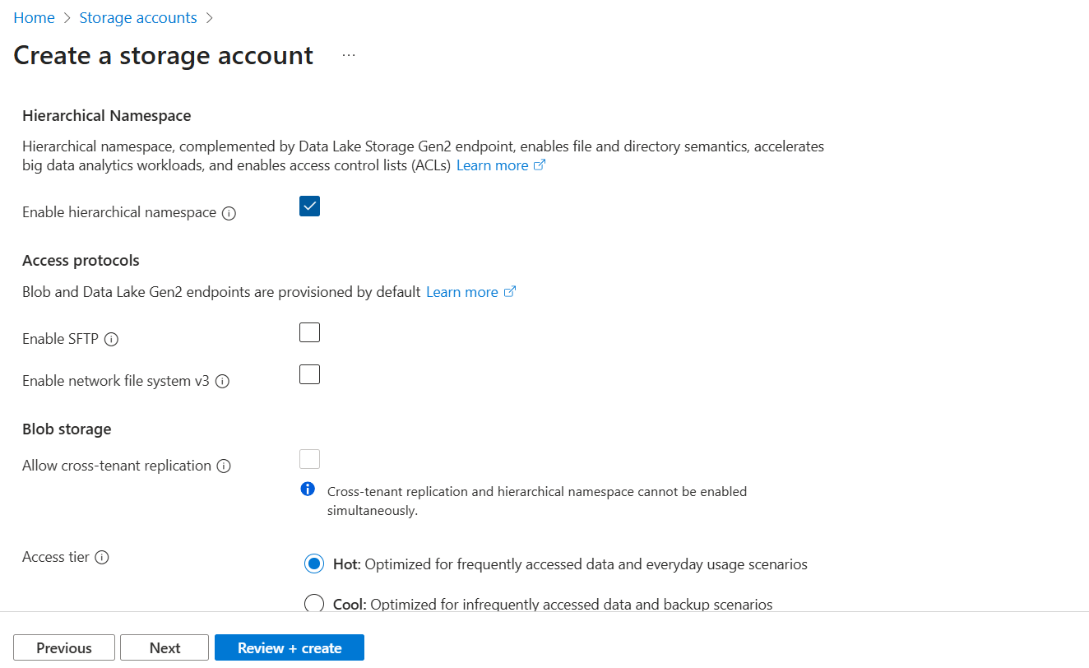

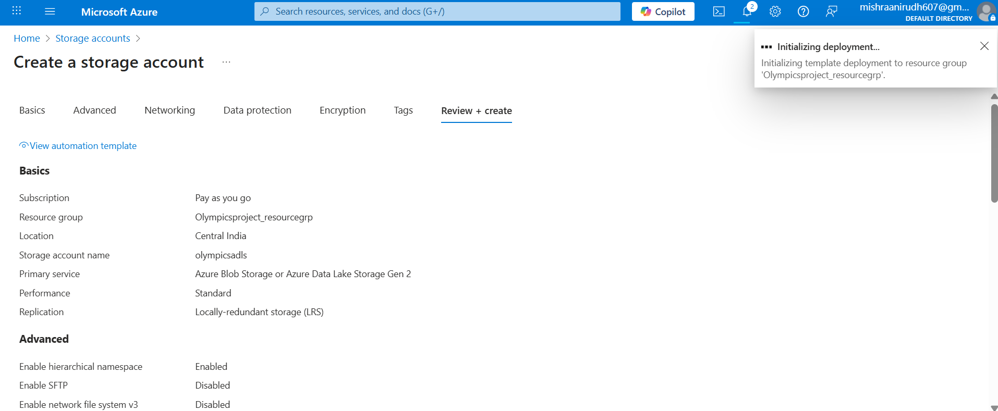

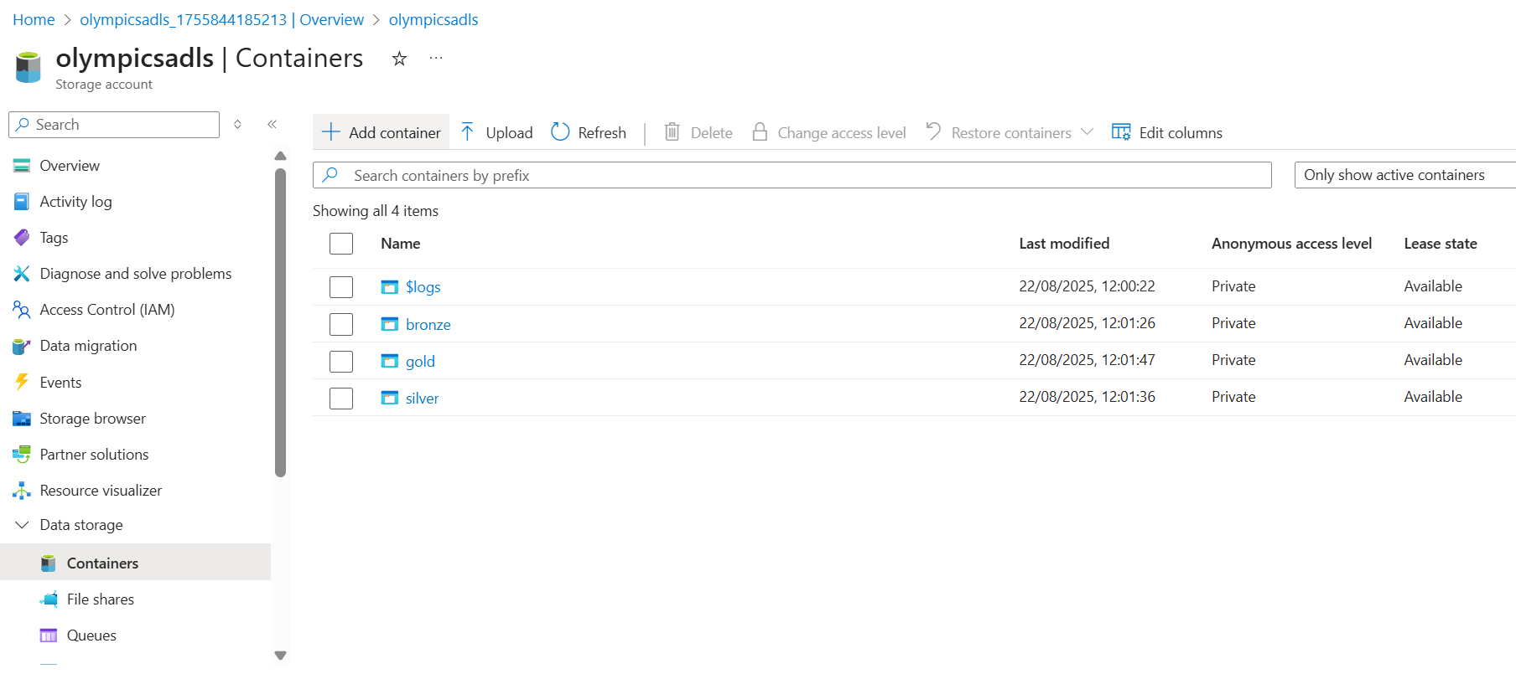

**3. Data Ingestion Pipeline (Azure Data Factory)**

* Created an Azure Data Factory (ADF) instance.
* Built a data pipeline in ADF that ingested the four CSV files directly from the GitHub repository and copied them into the bronze folder of the Azure Data Lake.
* Configured the pipeline to correctly handle the CSV format.

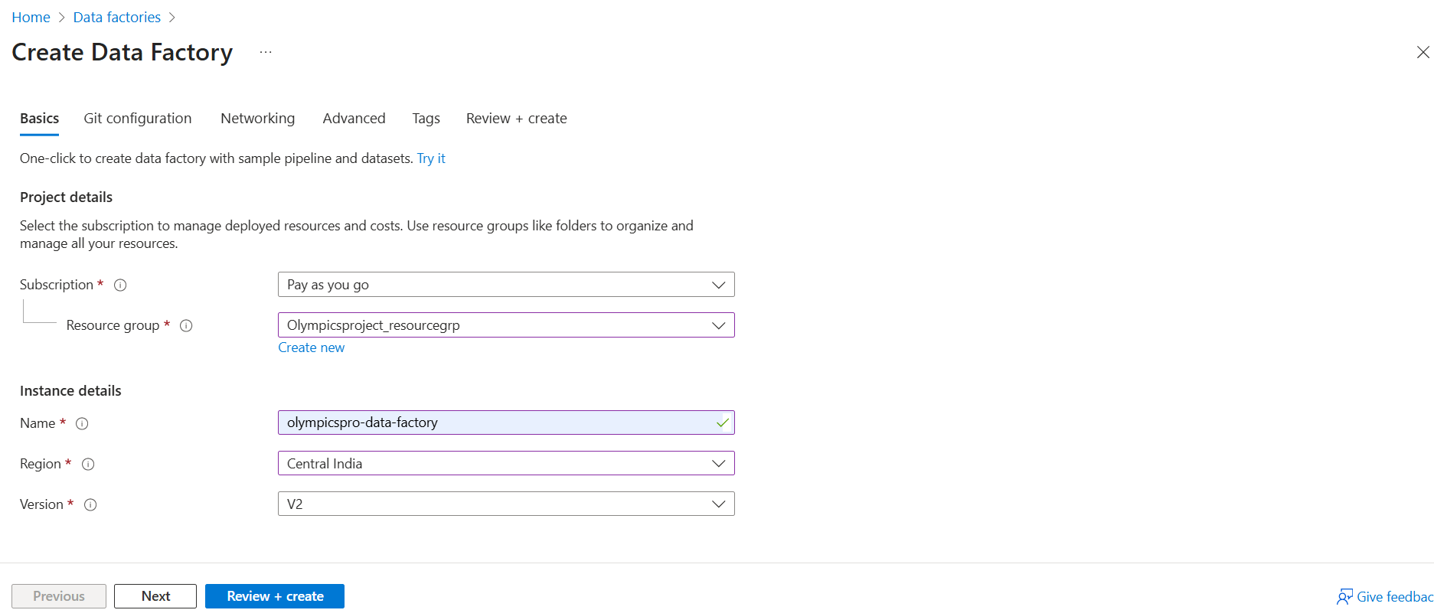

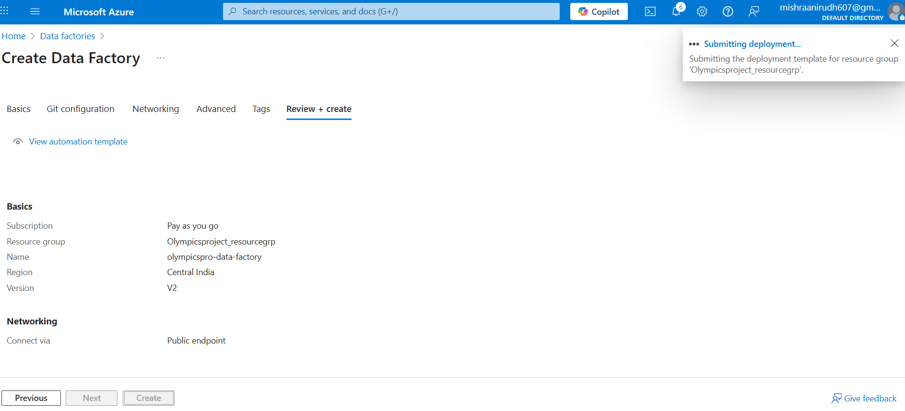

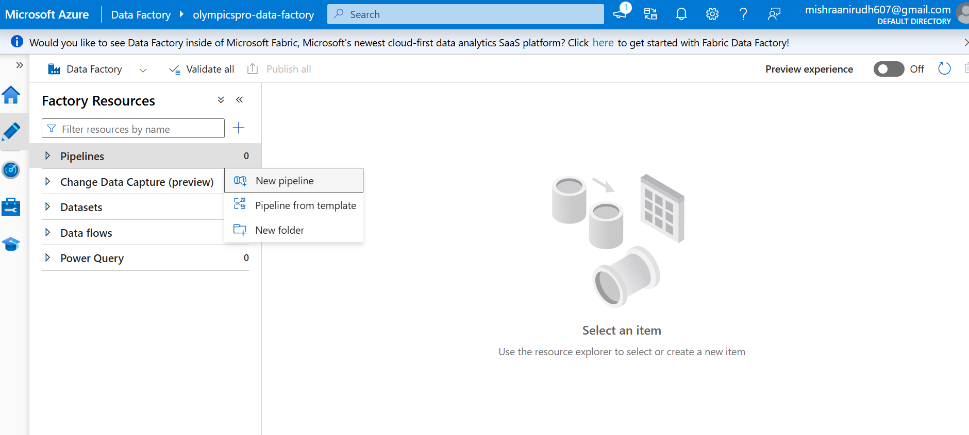

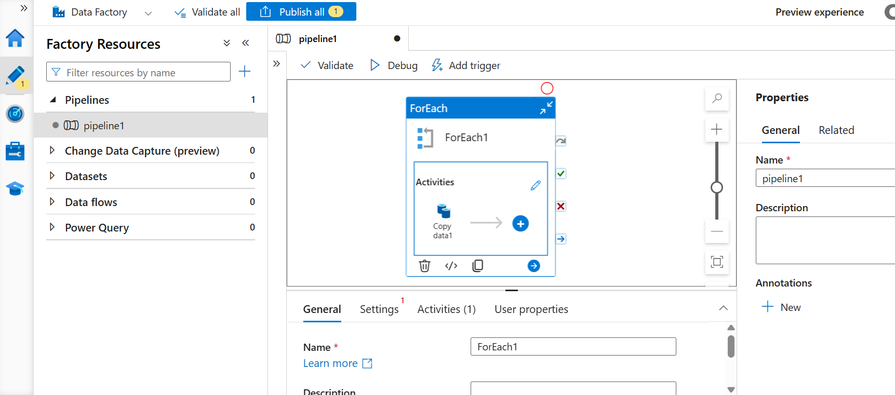

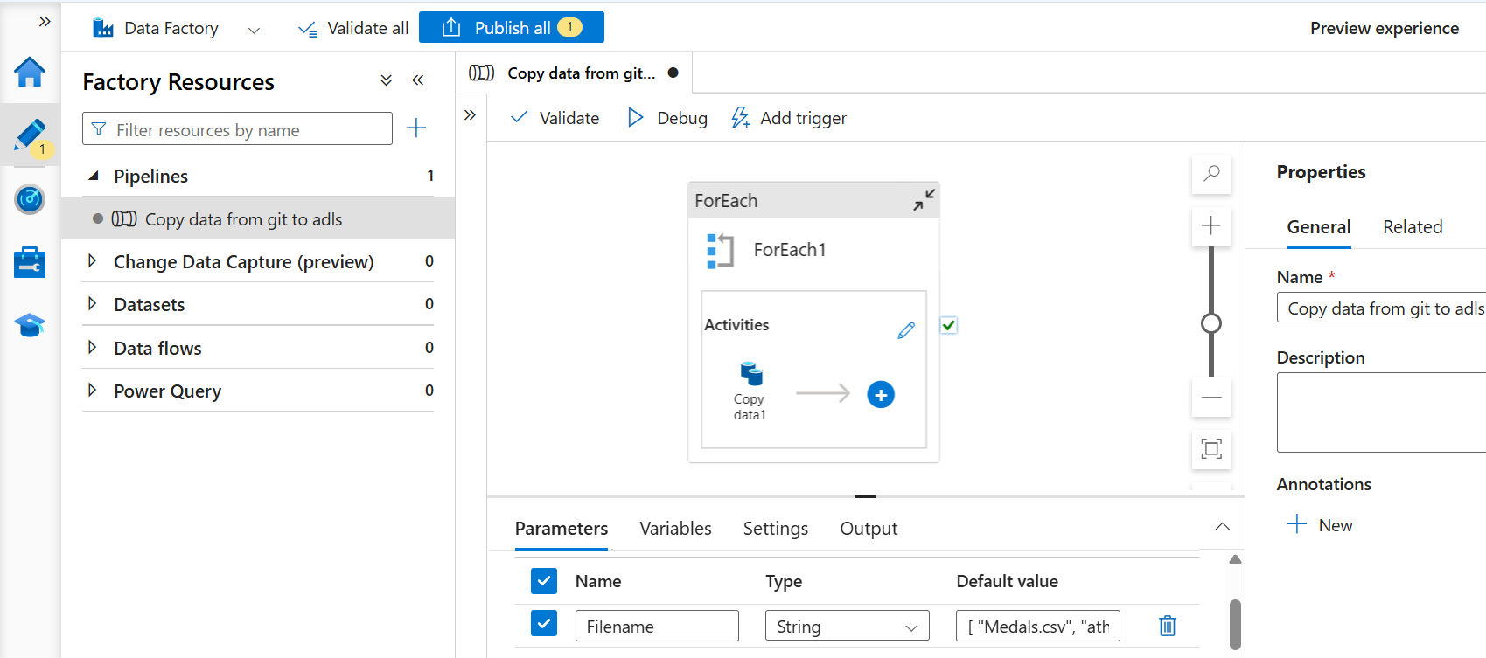

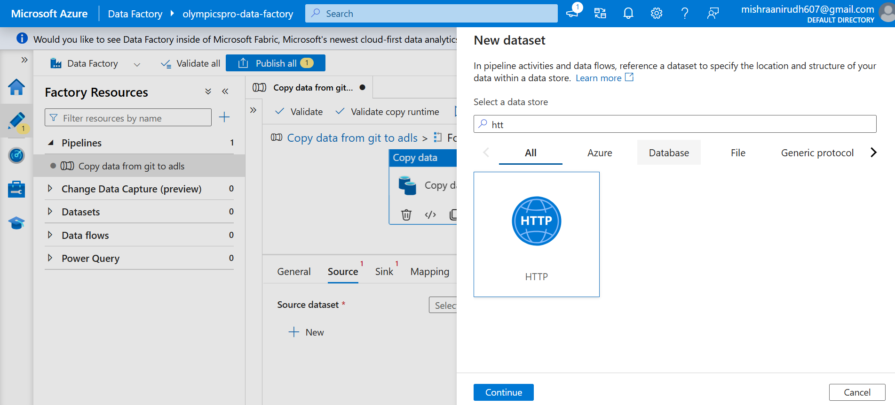

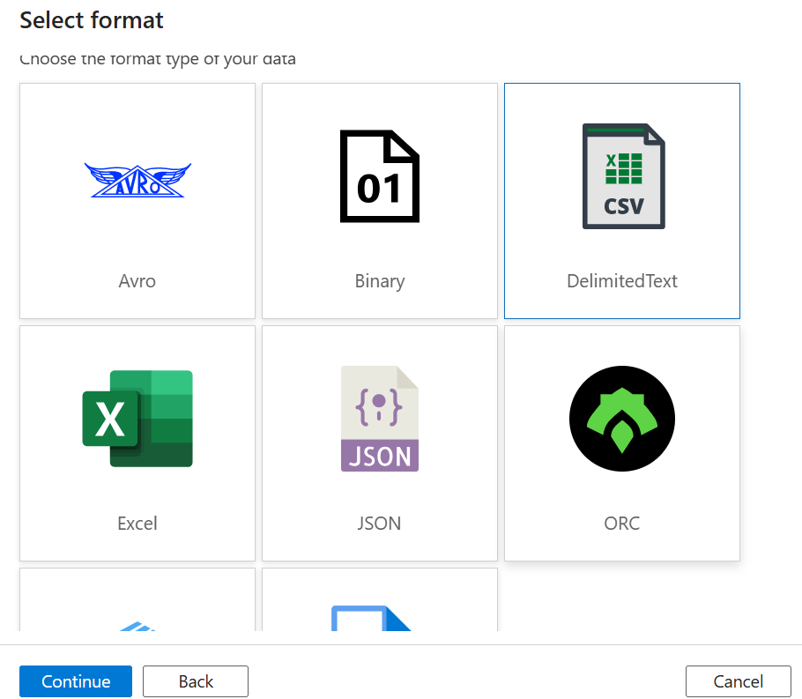

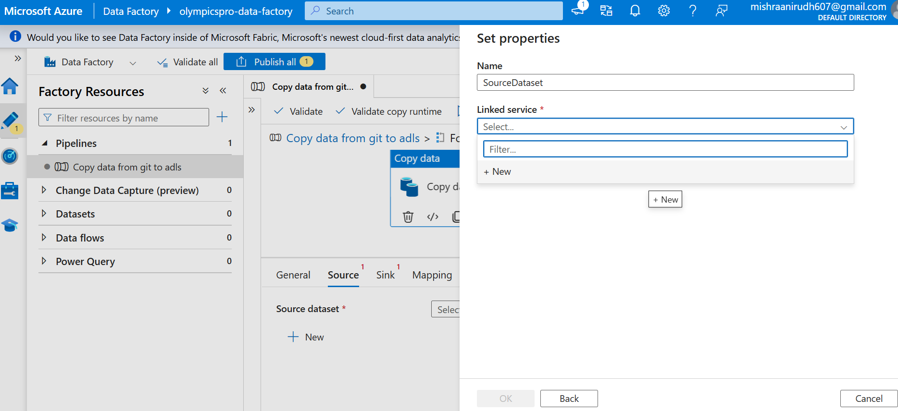

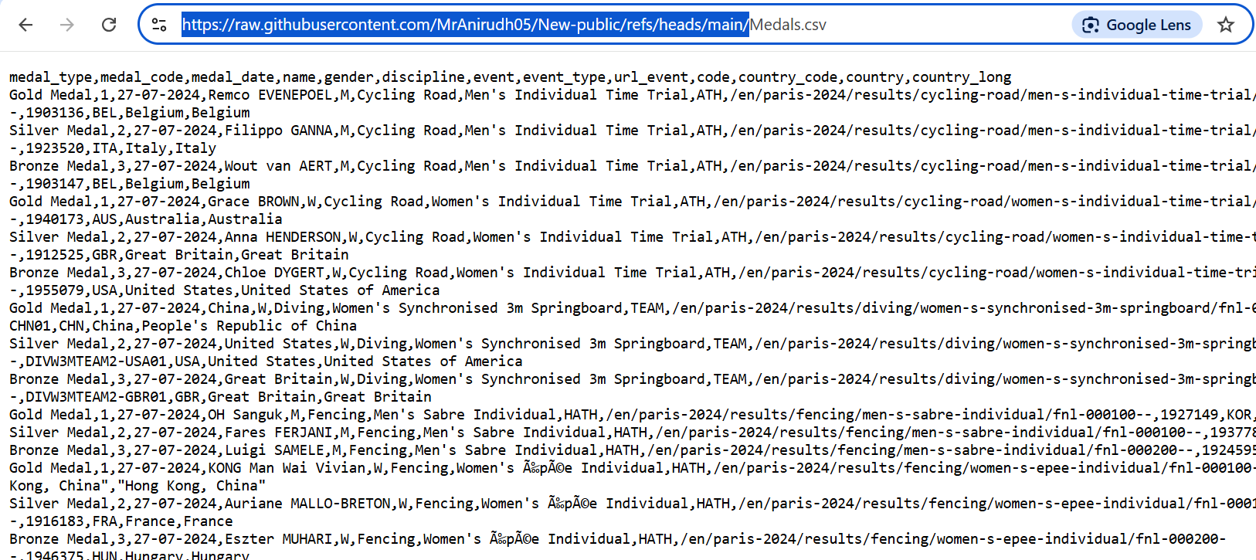

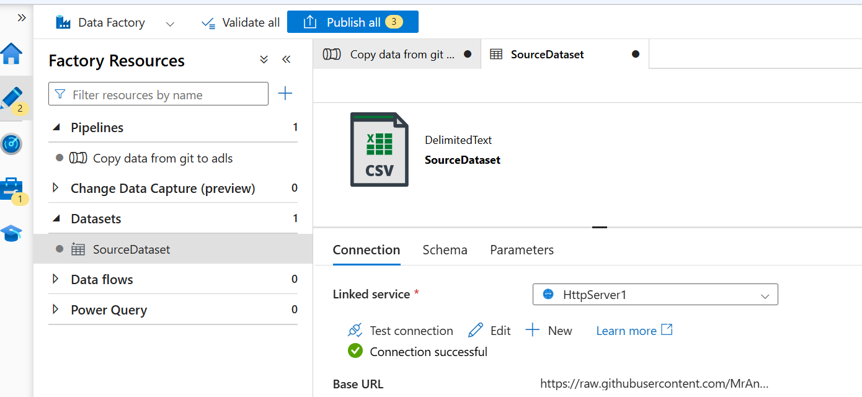

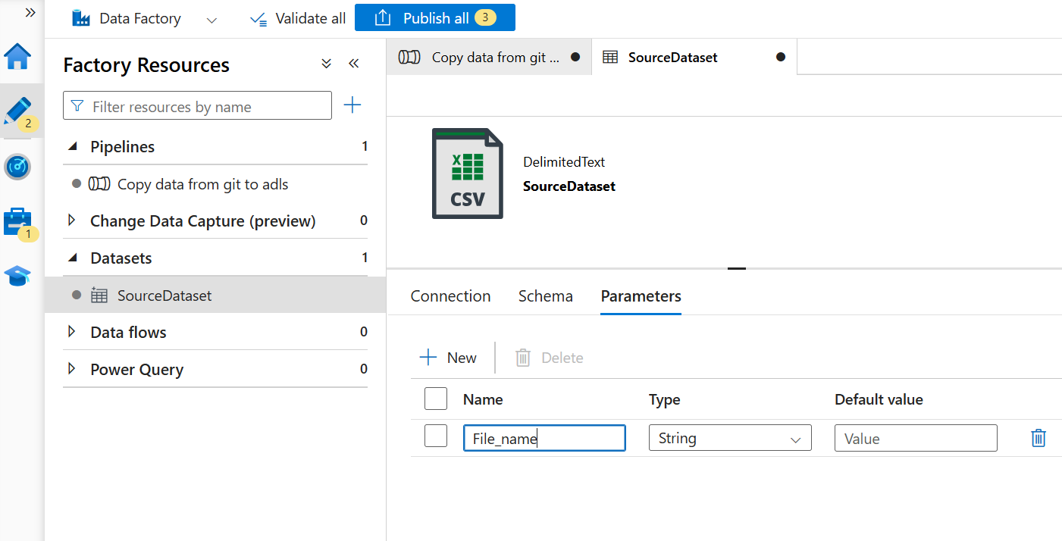

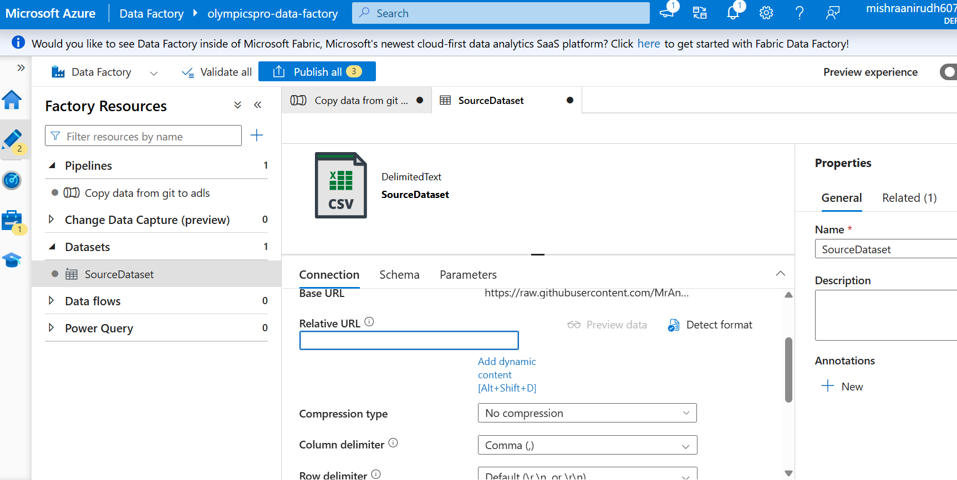

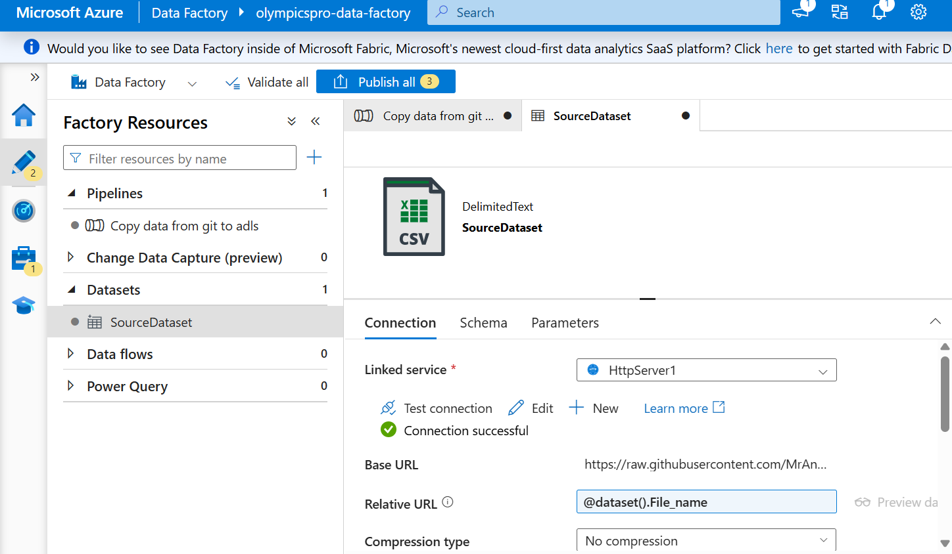

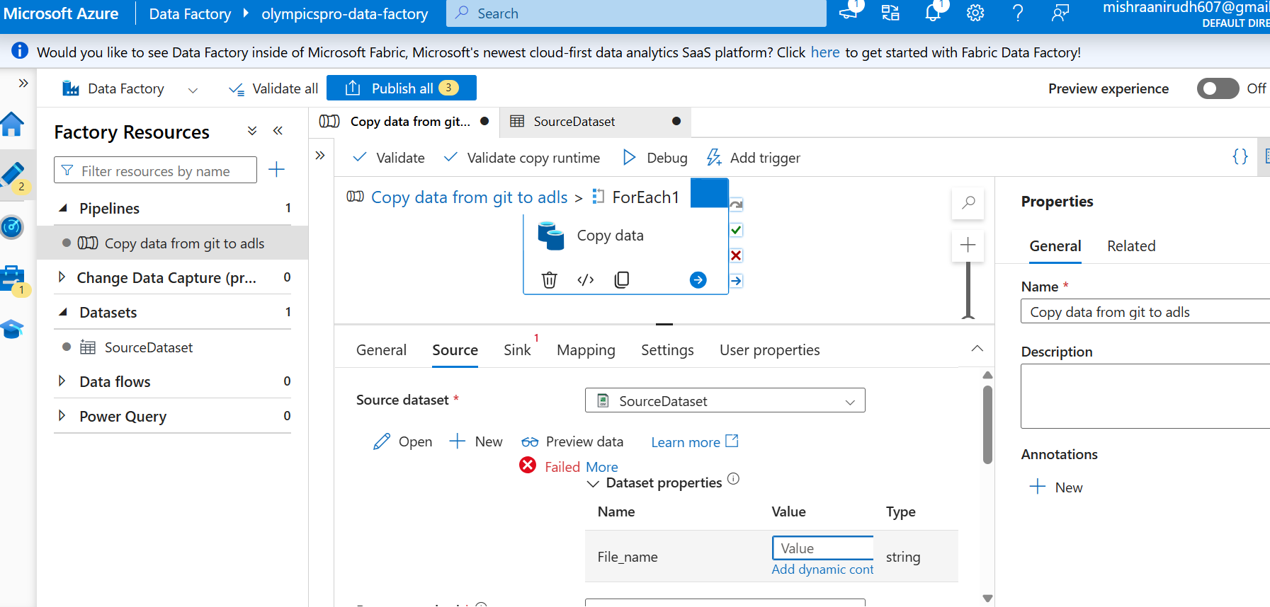

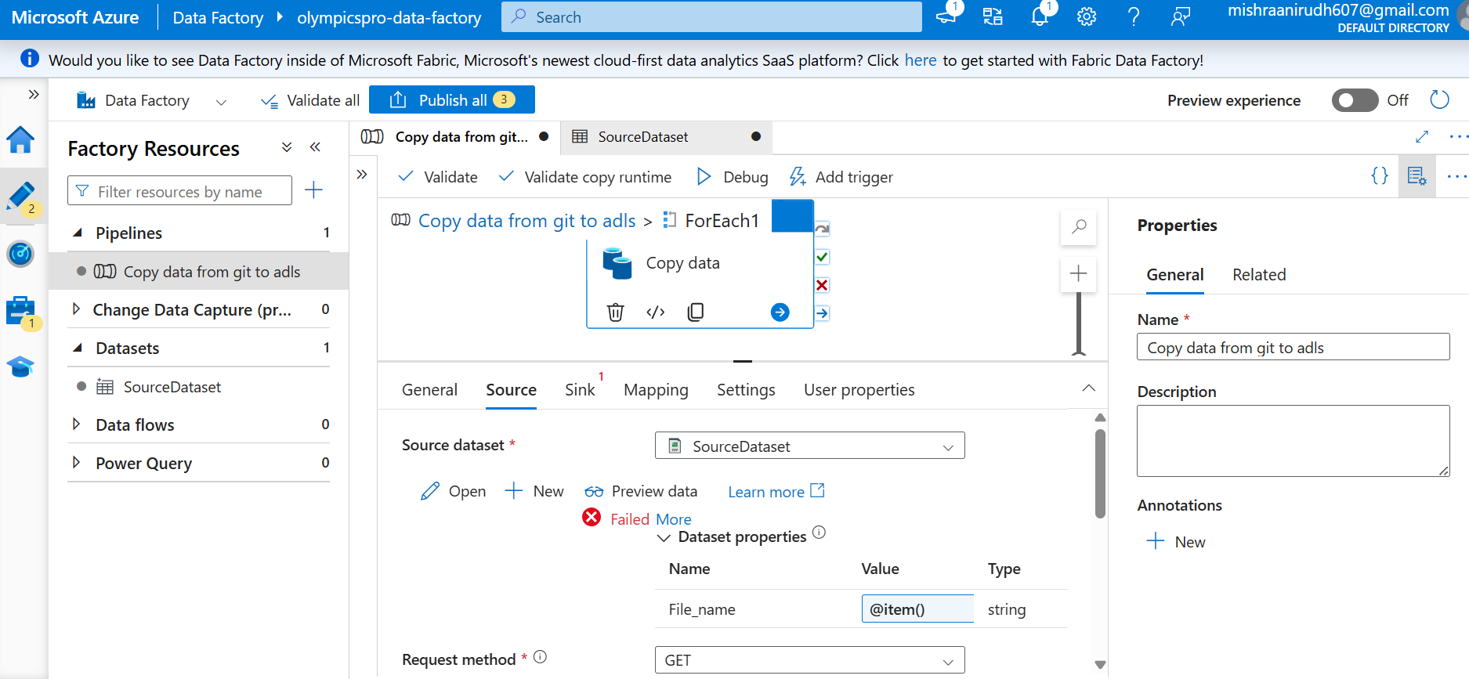

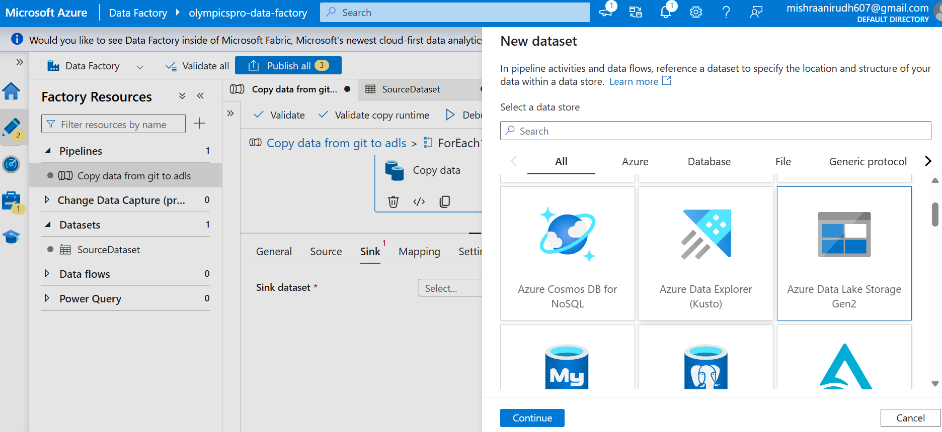

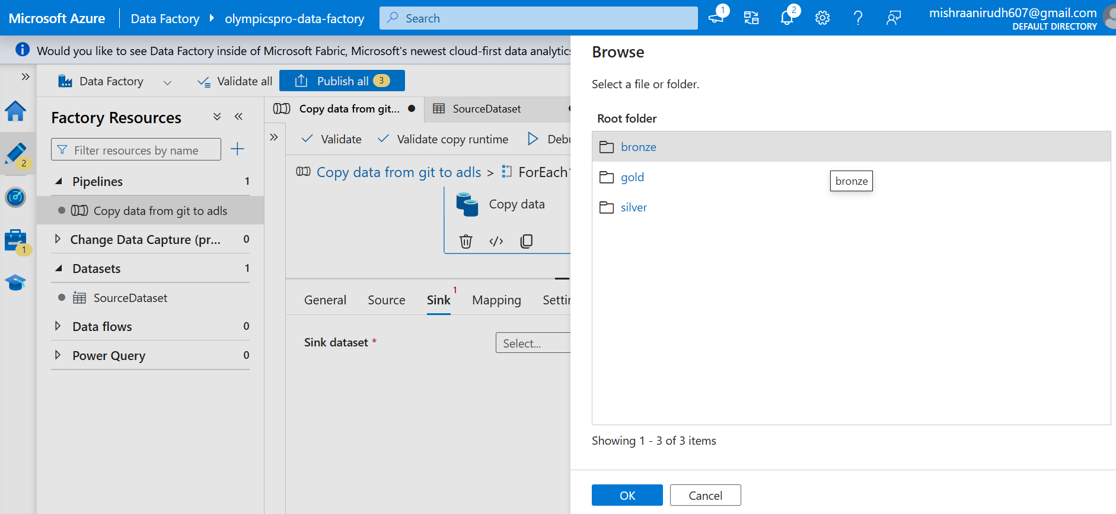

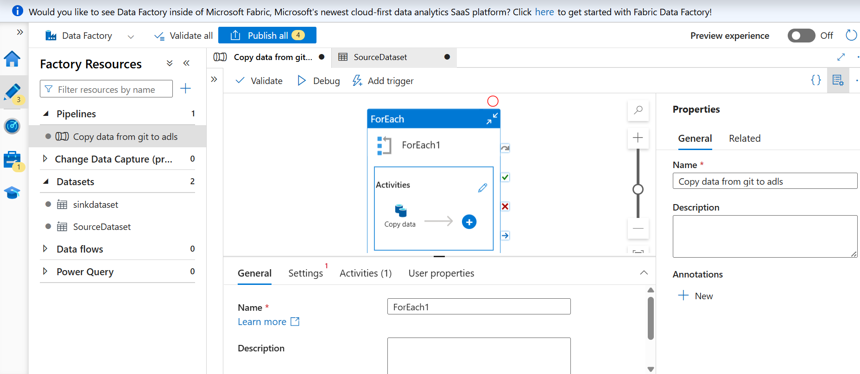

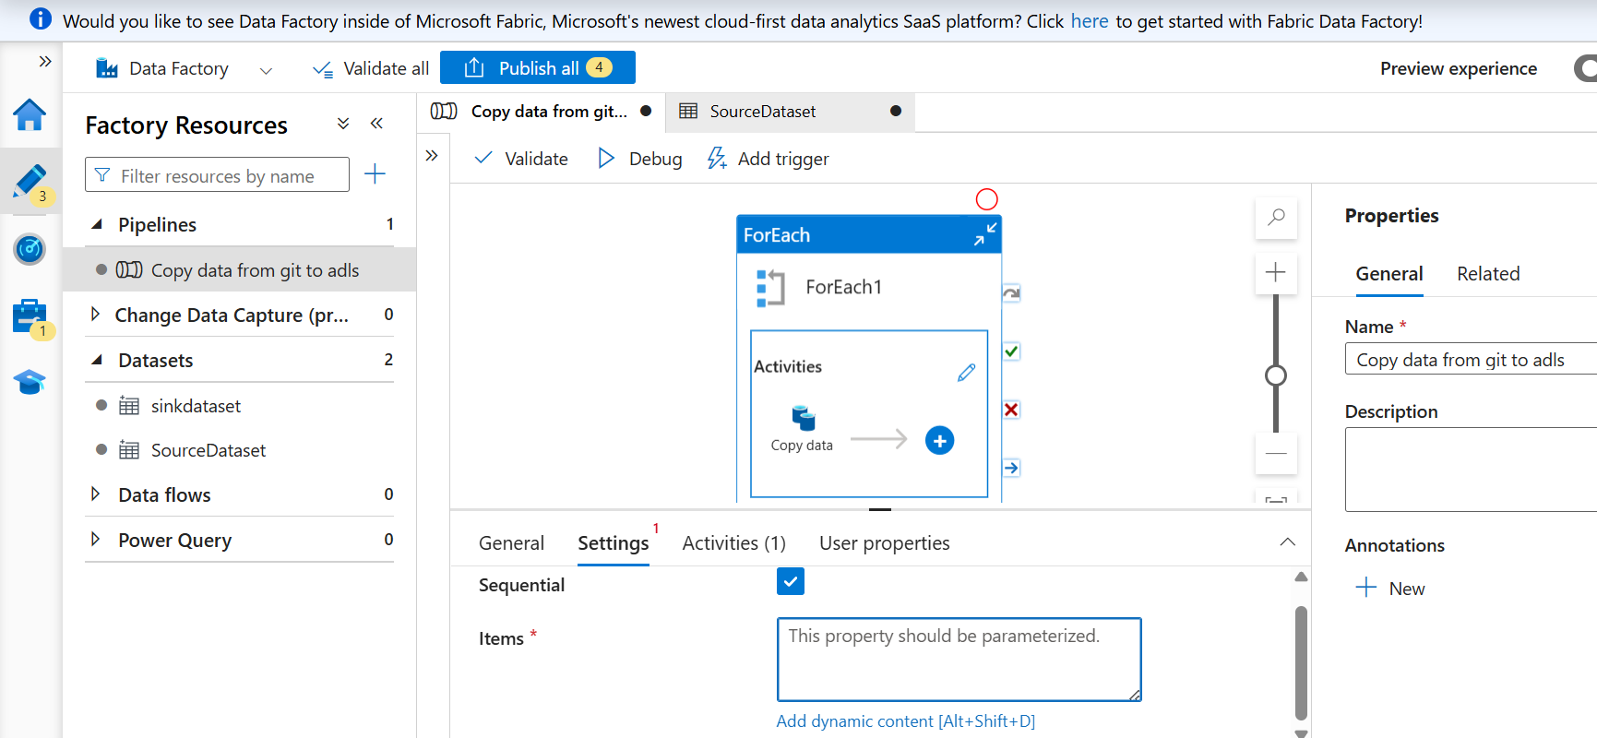

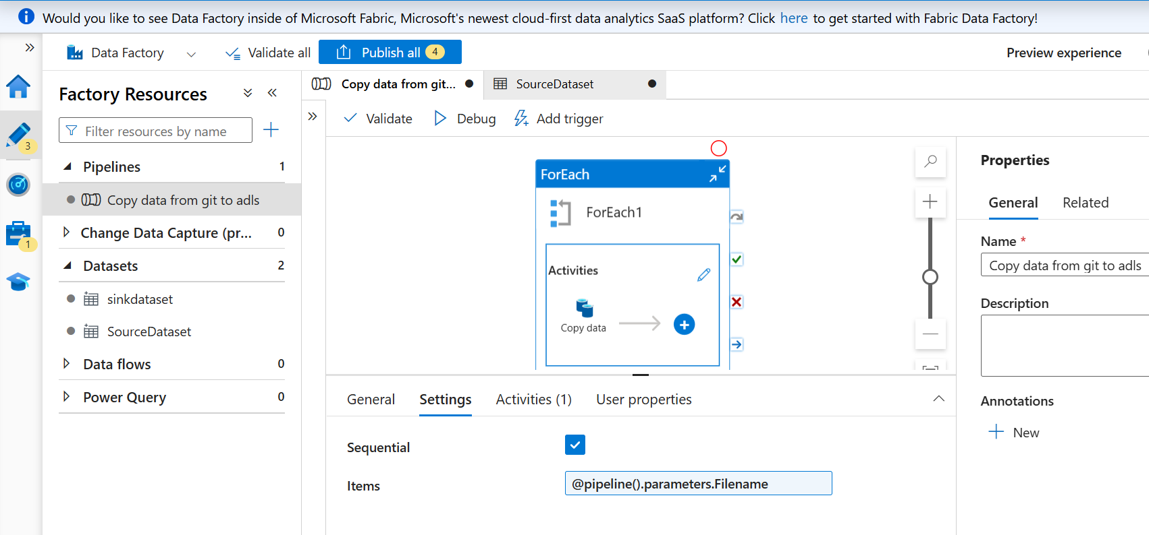

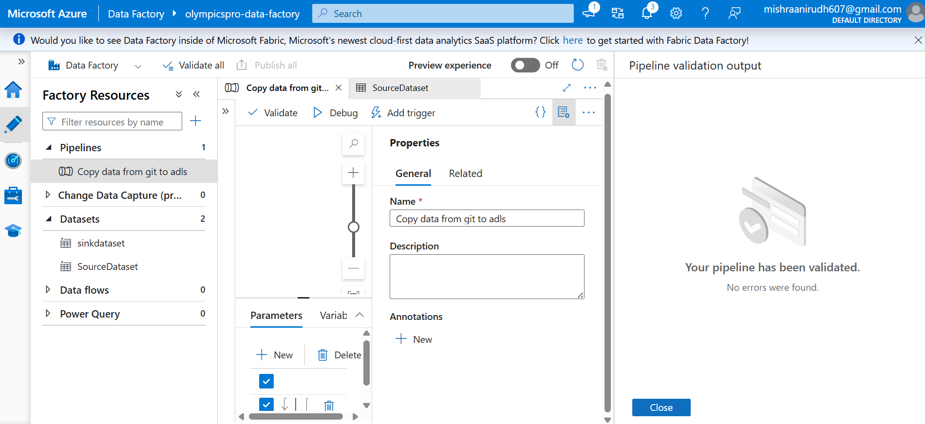

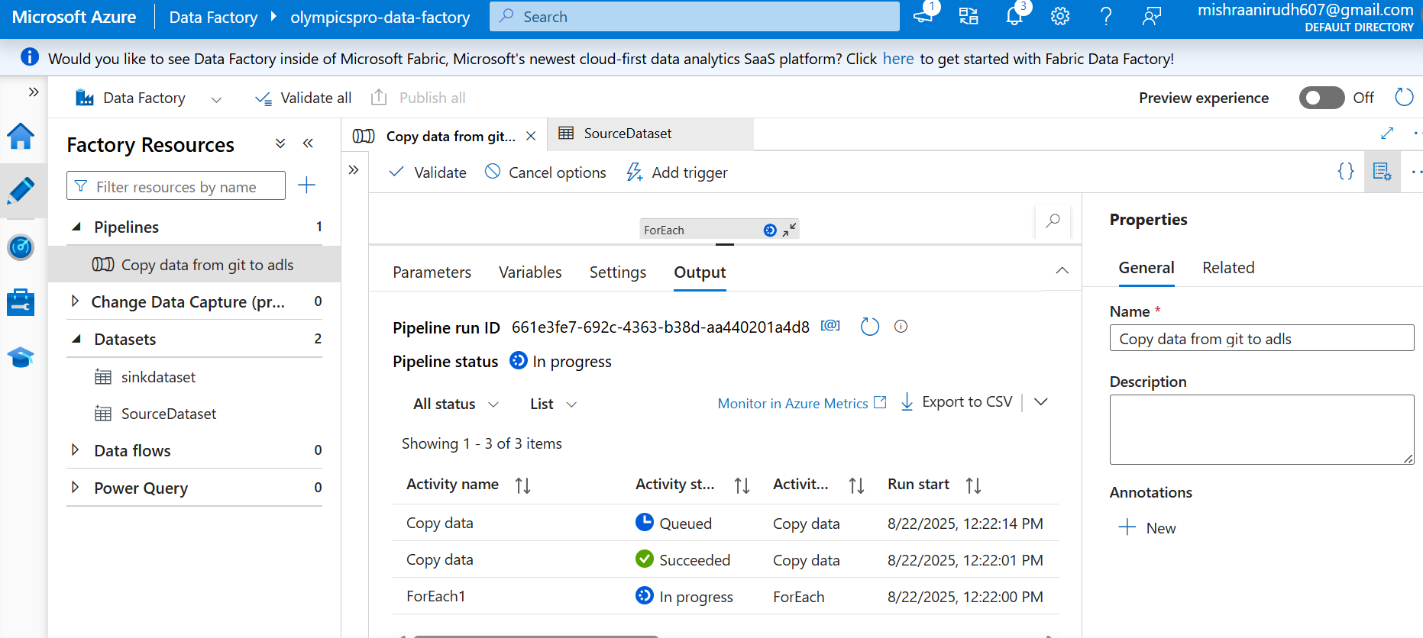

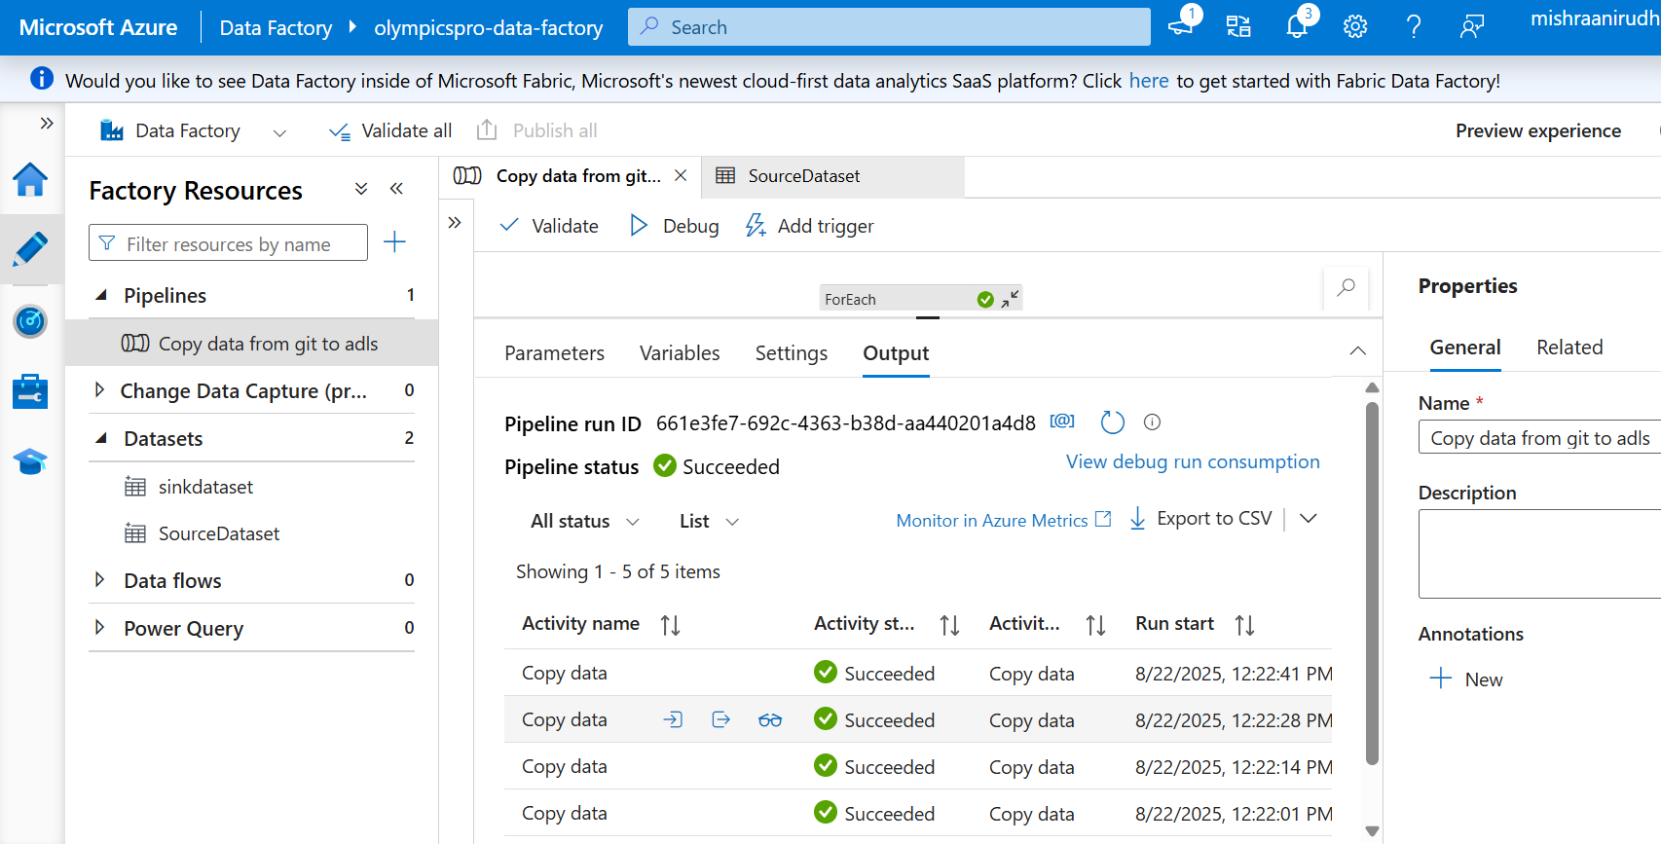

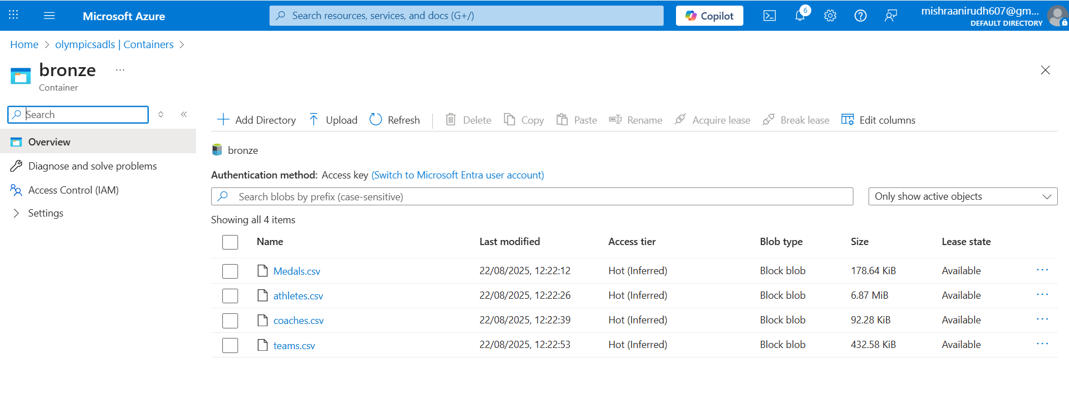

**Step-by-Step Pipeline flow Validation**

1. **Created Pipeline Parameters**
   * baseUrl (String) →
   * https://raw.githubusercontent.com/MrAnirudh05/New-public/main/
   * fileArray (Array) →
   * [
   * "medals.csv",
   * "athletes.csv",
   * "coaches.csv",
   * "teams.csv"
   * ]
2. **Added ForEach Activity**
   * Items →
   * @pipeline().parameters.fileArray
   * This loops over each file name in the array.
3. **Inside ForEach → Copy Activity**
   * **Sink (Blob/ADLS dataset)**
     + Parameterized file path → You pass item() to sink dataset, so each file lands with its actual name.
4. **Datasets**
   * **HTTP Dataset**
     + Linked service: HTTP
     + URL → left blank or set dynamically through parameter
   * **Blob/ADLS Dataset**
     + Parameter for file name
     + Path set as:
     + @dataset().fileName

(and passed item() from ForEach)

1. **Validation**
   * When you debugged, each file should be picked like:
   * https://raw.githubusercontent.com/MrAnirudh05/New-public/main/medals.csv
   * https://raw.githubusercontent.com/MrAnirudh05/New-public/main/athletes.csv
   * ...
   * Each one successfully lands in sink storage.

✅ This design is clean:

* **No hardcoding** of file names
* **Reusable** pipeline (just change fileArray param)
* **Scalable** if we add more CSVs in future

| **Step** | **How it’s handled** |
| --- | --- |
| **Linked Service (HTTP)** | Base URL is fixed here → https://raw.githubusercontent.com/MrAnirudh05/New-public/main/ |
| **Dataset (HTTP)** | Has a parameter fileName. Relative URL is set as @dataset().fileName |
| **ForEach Activity** | Iterates over ["medals.csv","athletes.csv","coaches.csv","teams.csv"] |
| **Copy Activity** | Passes item() → fileName parameter |
| **Final URL** | Linked service base URL + dataset relative URL → .../main/medals.csv etc. |

**Phase 2: Data Transformation & Cleaning (Azure Databricks)**

**1. Databricks Workspace**

* **Created an Azure Databricks workspace** and connected it to the Data Lake.
* **Created a new notebook** (e.g., data_transformation.py) for this phase.

Setting up the cluster-

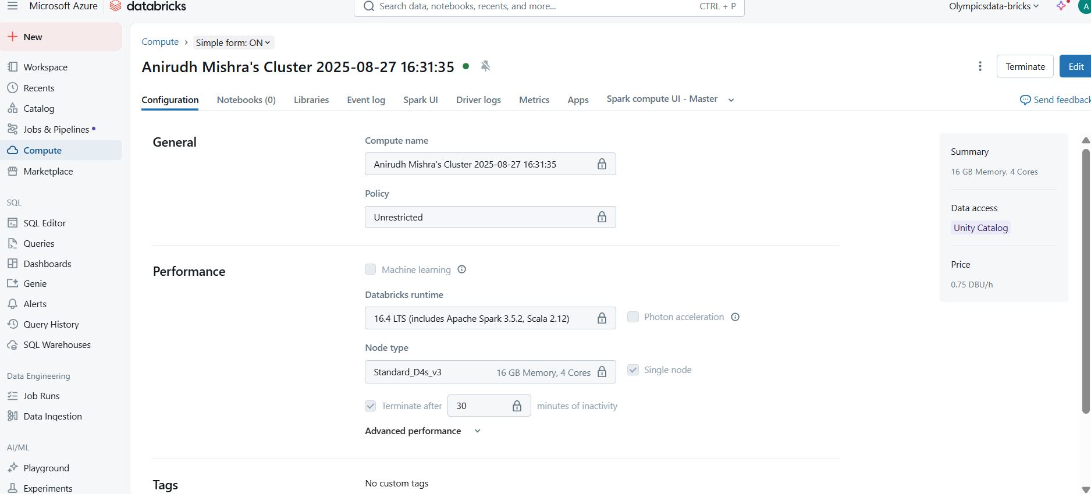

**ADLS TO DATABRICKS CONNECTION VIA SERVICE PRINCIPAL**

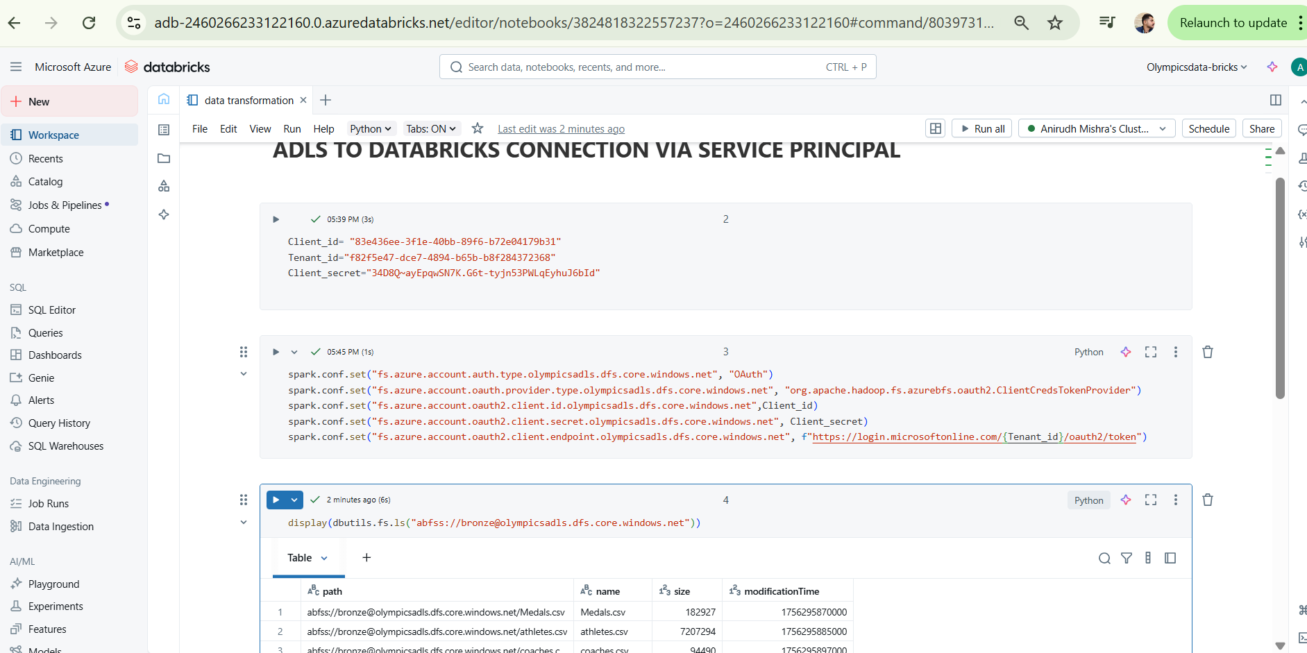

**2. Bronze to Silver Transformation**

* **Loaded the raw CSV data from the bronze folder into Databricks DataFrames for each of the four datasets.**

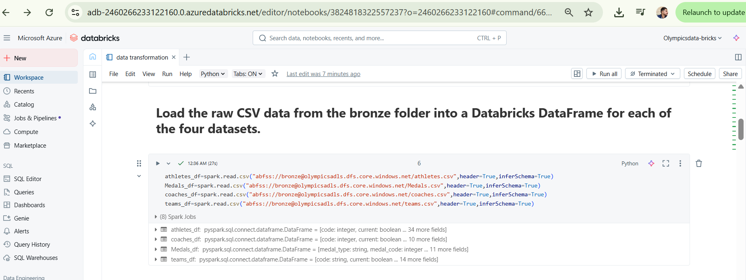

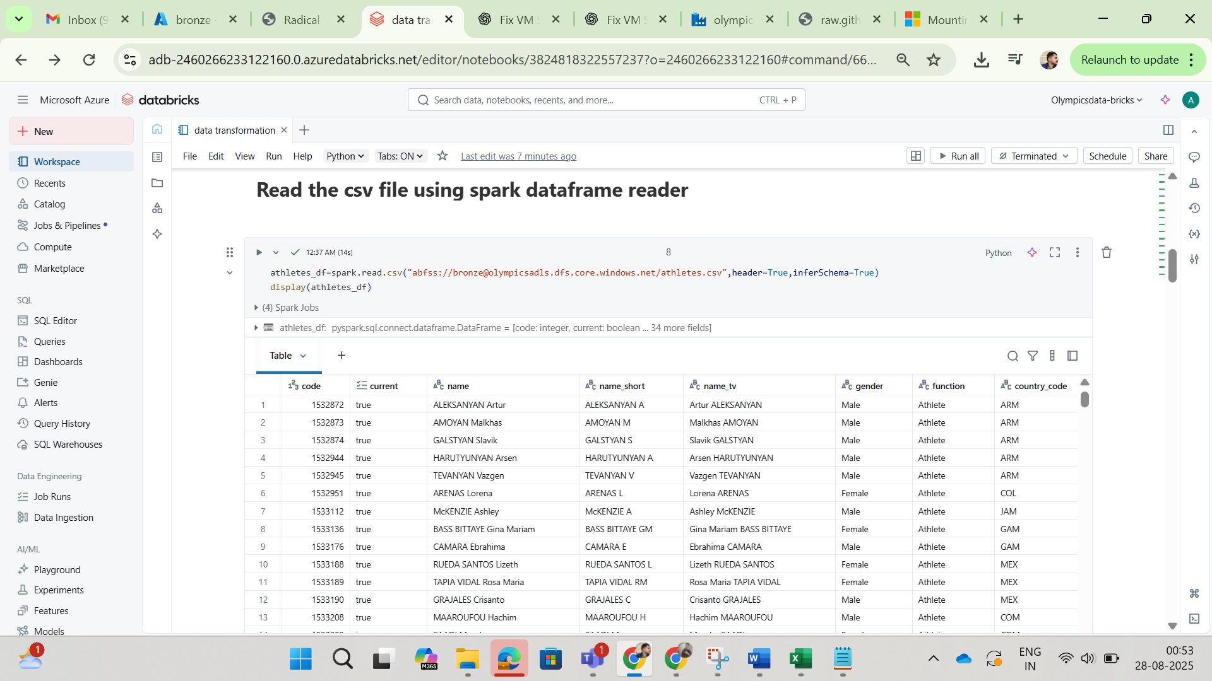

Performed data cleaning and transformation steps as follows:

* **Handled Missing Values**: Identified and addressed null values. For columns such as *height* and *weight* in athletes.csv, filled null values with 0 or the median. For critical identifier columns, dropped records containing nulls to maintain data integrity.

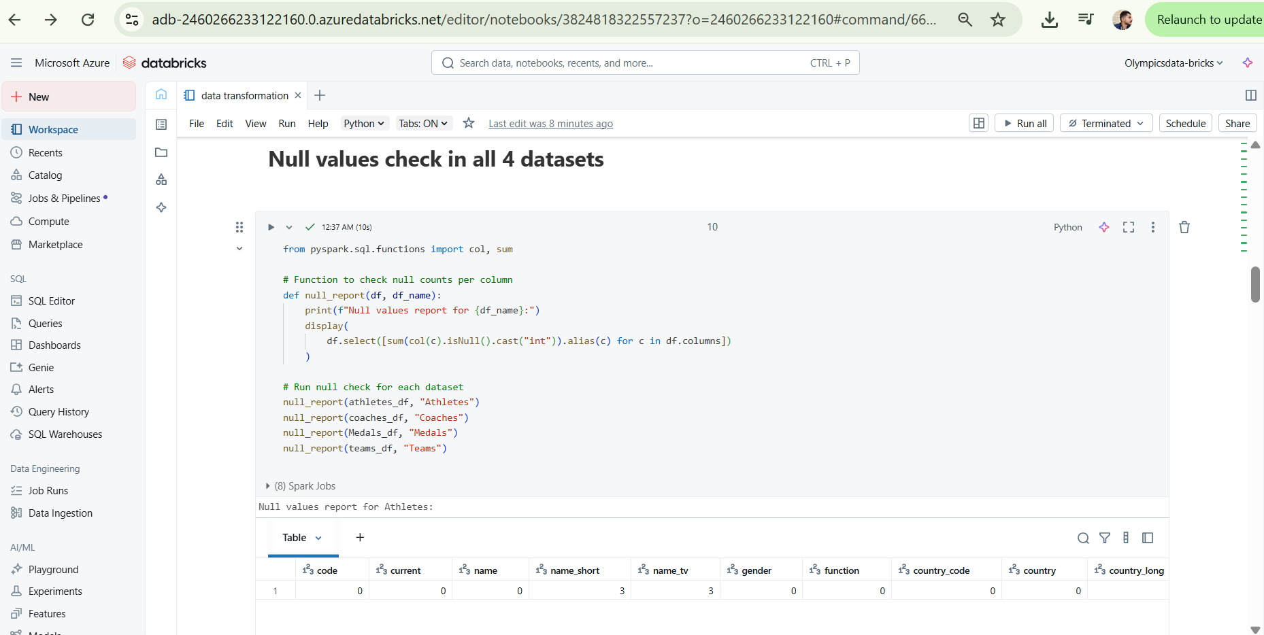

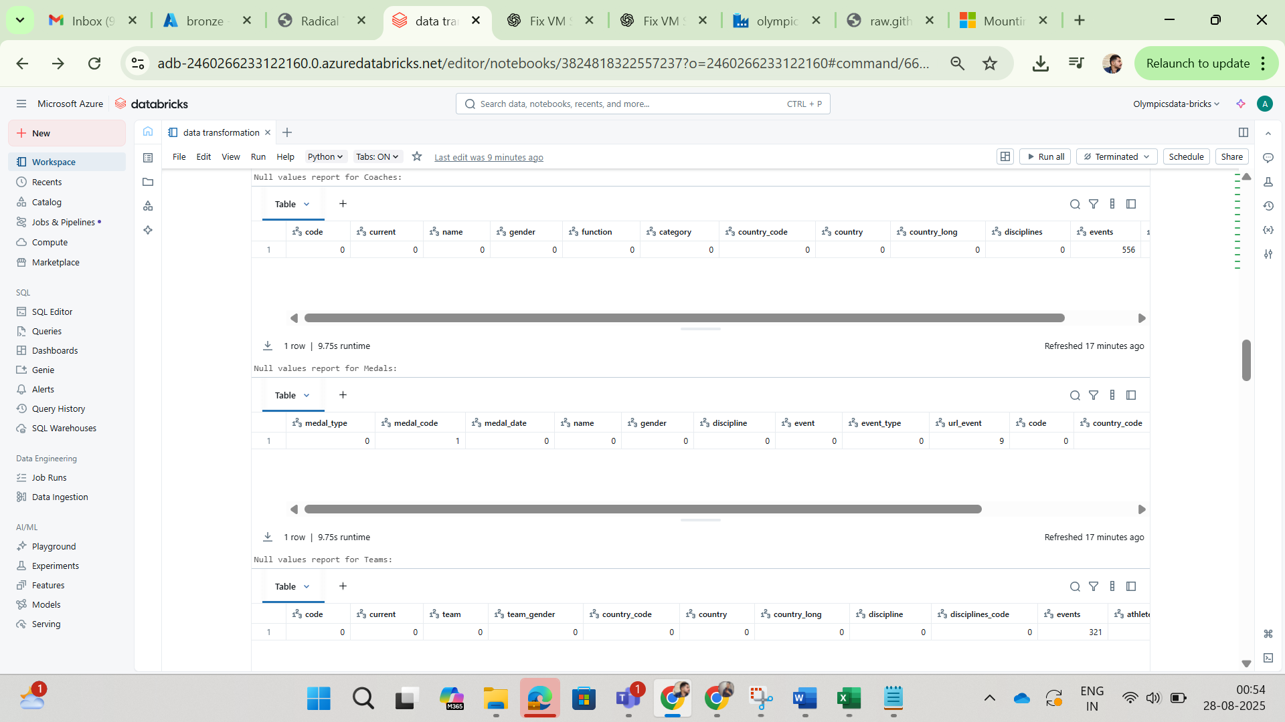

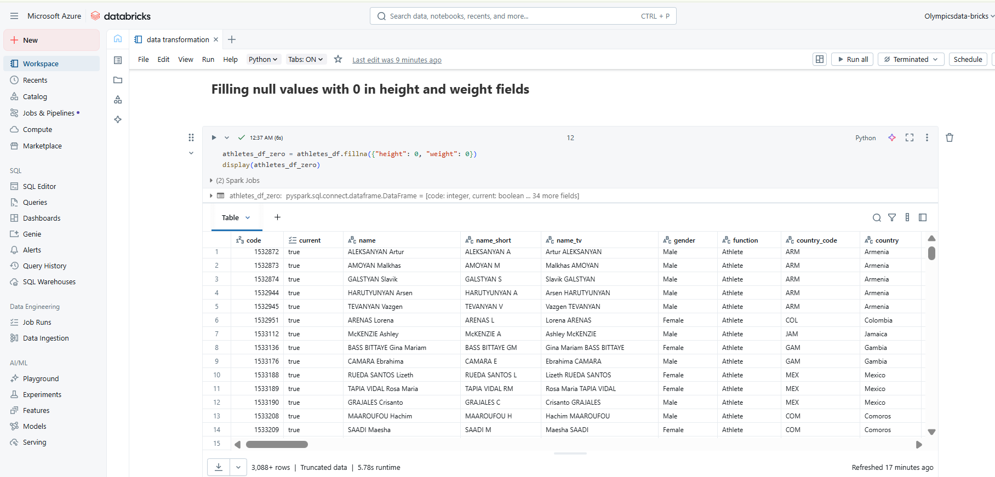

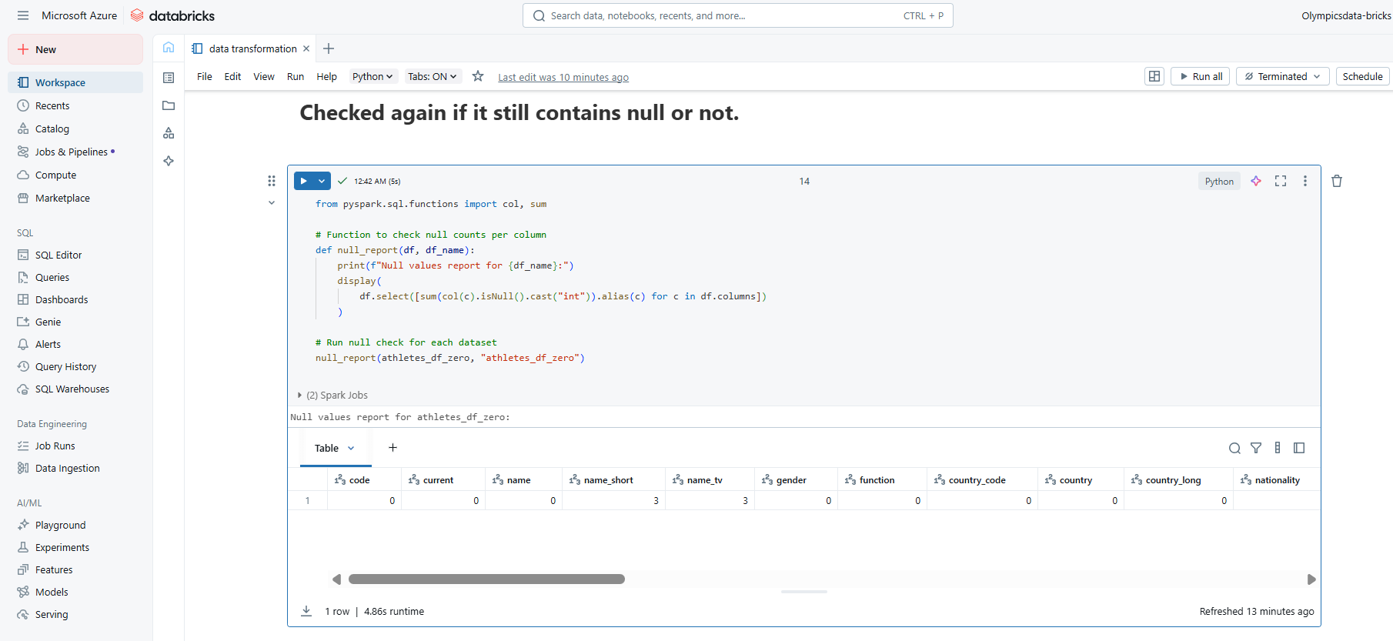

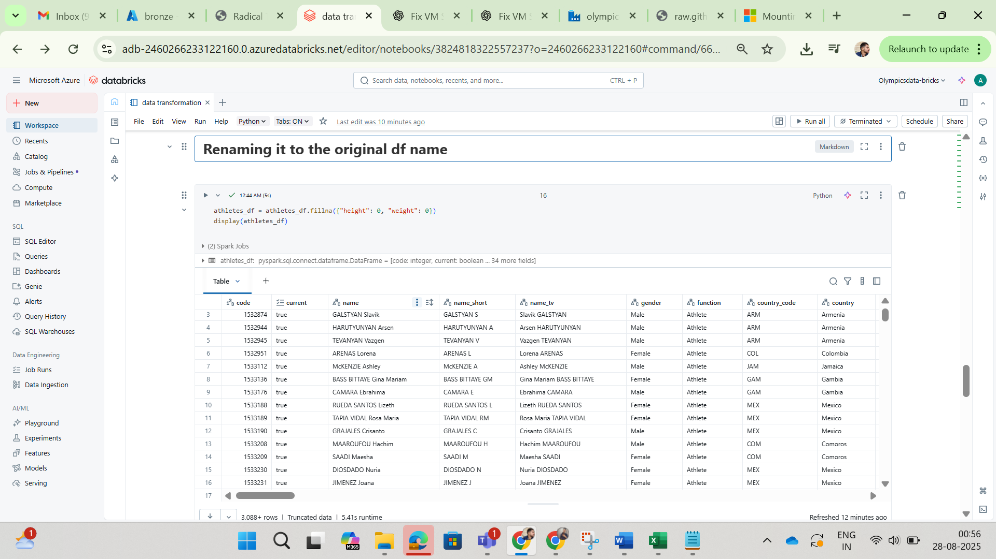

**Corrected Data Types:**

* Parsed the **athletes_codes** and **coaches_codes** columns in teams.csv, which were originally strings formatted like arrays (e.g., "['1913366', '1913367', '1913369']"), into proper array data types.
* Ensured all numeric columns were correctly cast to either integers or floats as required.

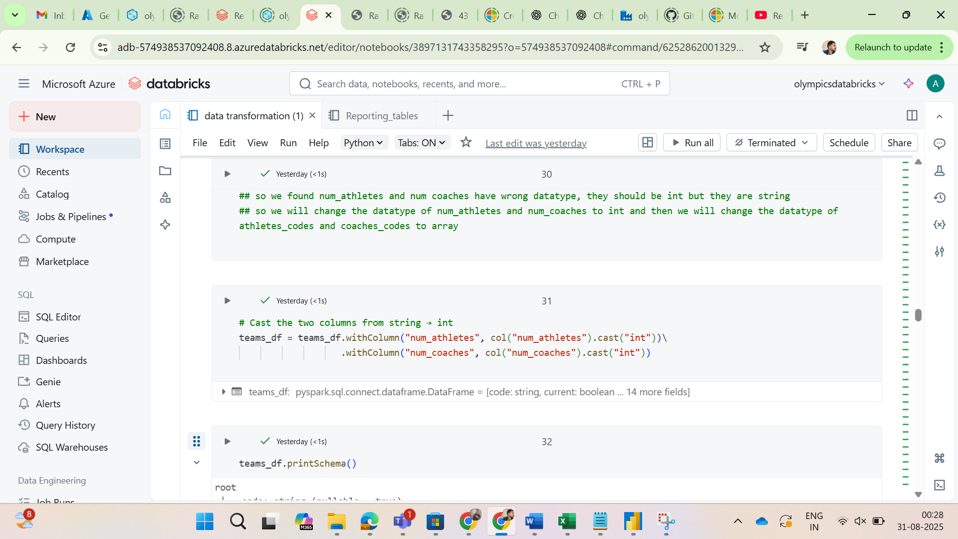

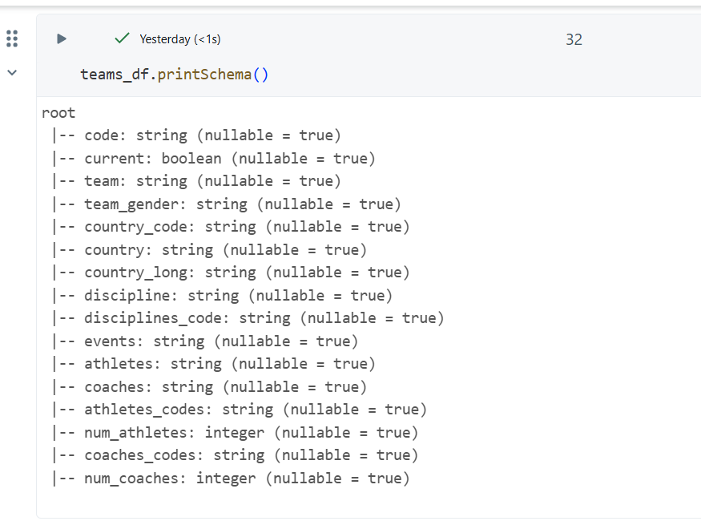

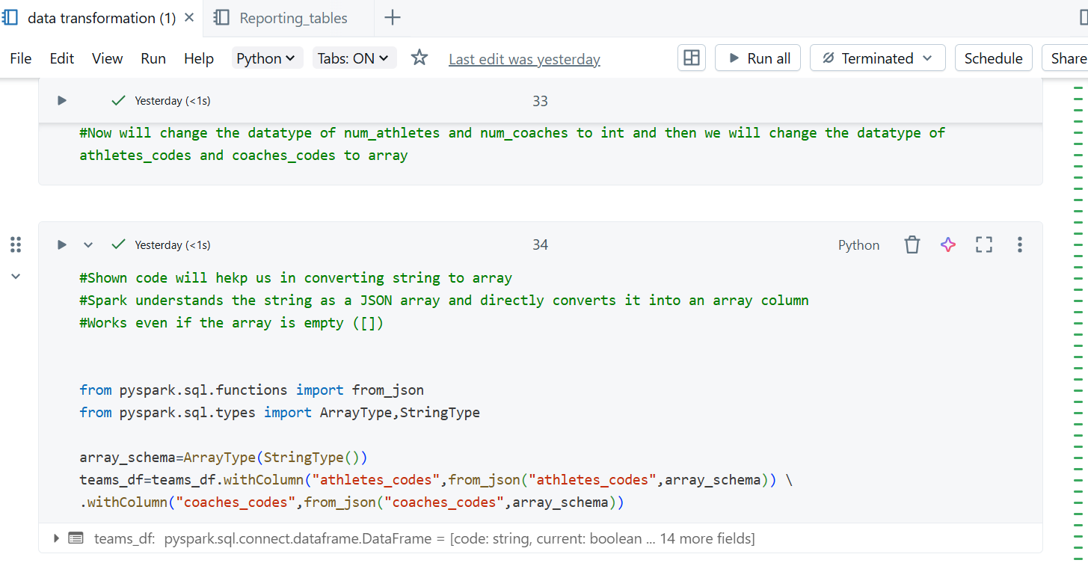

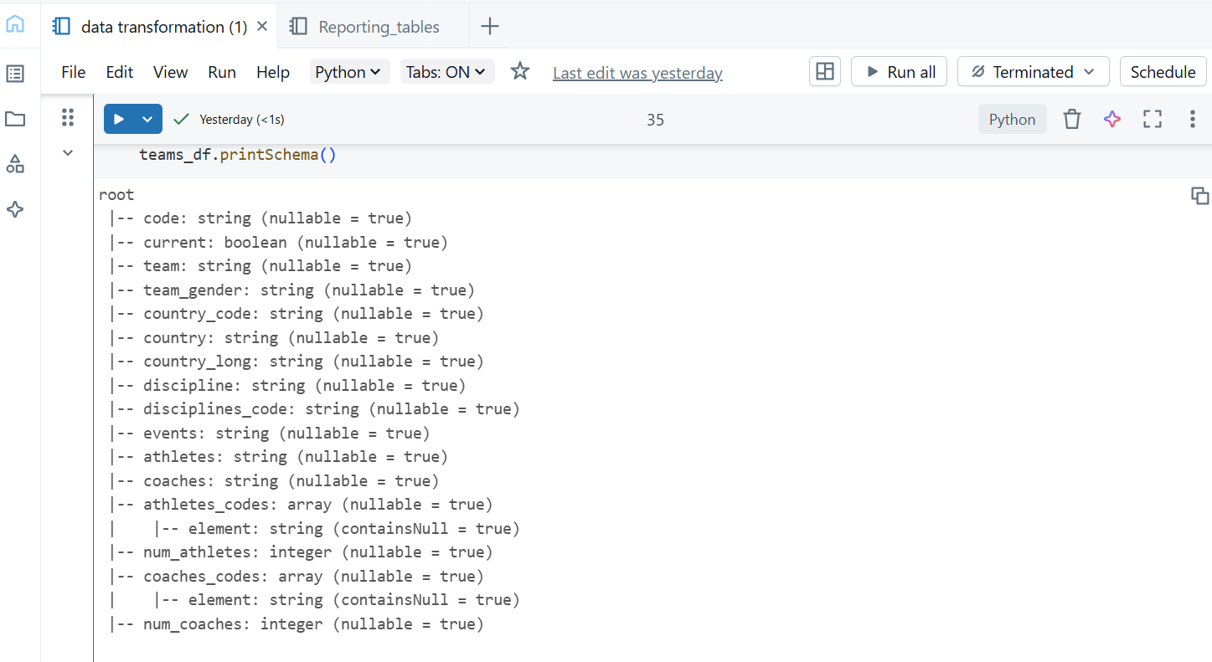

**Standardized Columns:** Renamed and standardized all column names to be consistent across the four datasets. Adopted snake_case naming conventions (e.g., medal_type, country_long) to ensure uniformity and make them easier to work with in code.

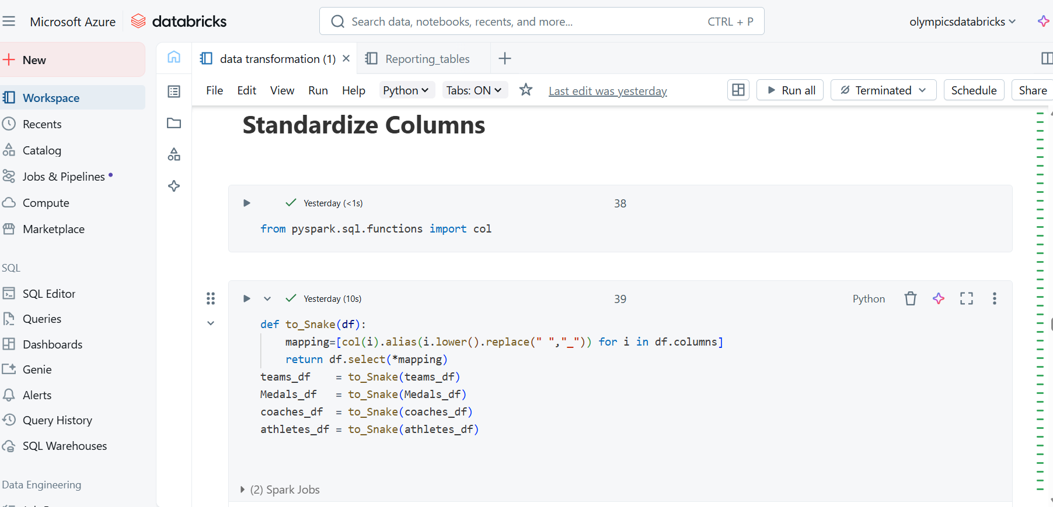

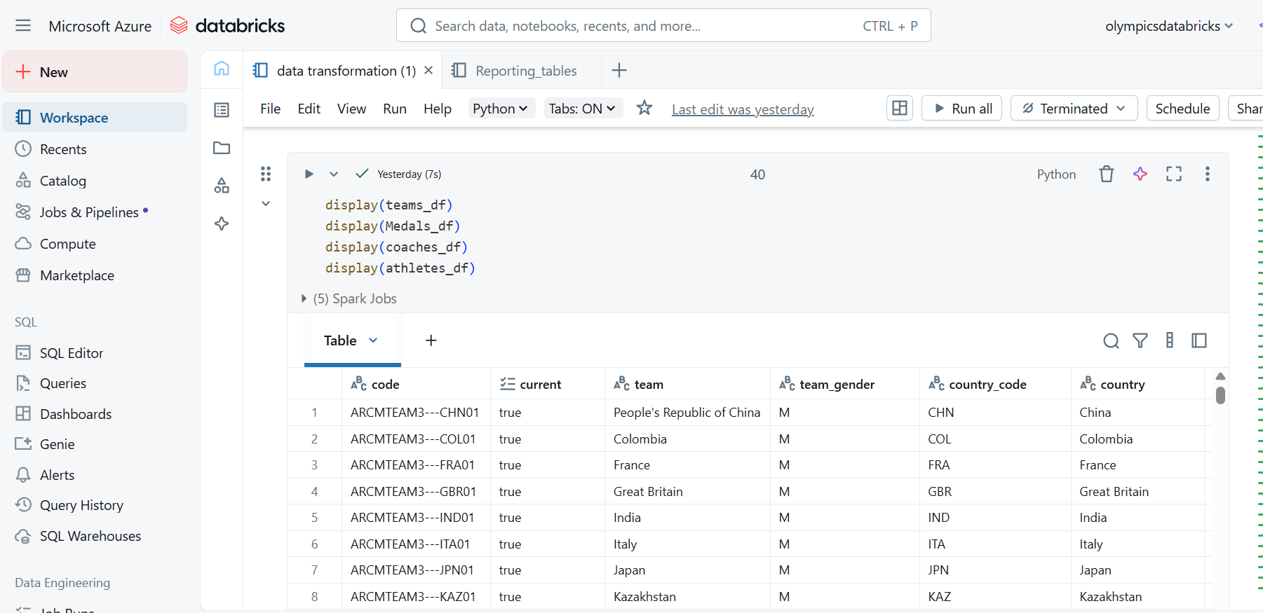

**3. Data Joins**

* **Performed multiple meaningful joins between the datasets to create richer information:**
  + Joined medals.csv and athletes.csv on the athlete code to enrich the medal data with athlete details such as name, gender, and country.
  + Joined medals.csv and teams.csv on the team code to incorporate team-specific information for medals awarded to teams.
  + Joined teams.csv and coaches.csv on the coaches_codes field, which was first transformed into an array and then exploded to link specific teams to their coaches.
* **Wrote the processed and enriched data as a single Delta table in the silver folder, which served as the primary source for all subsequent analysis.**

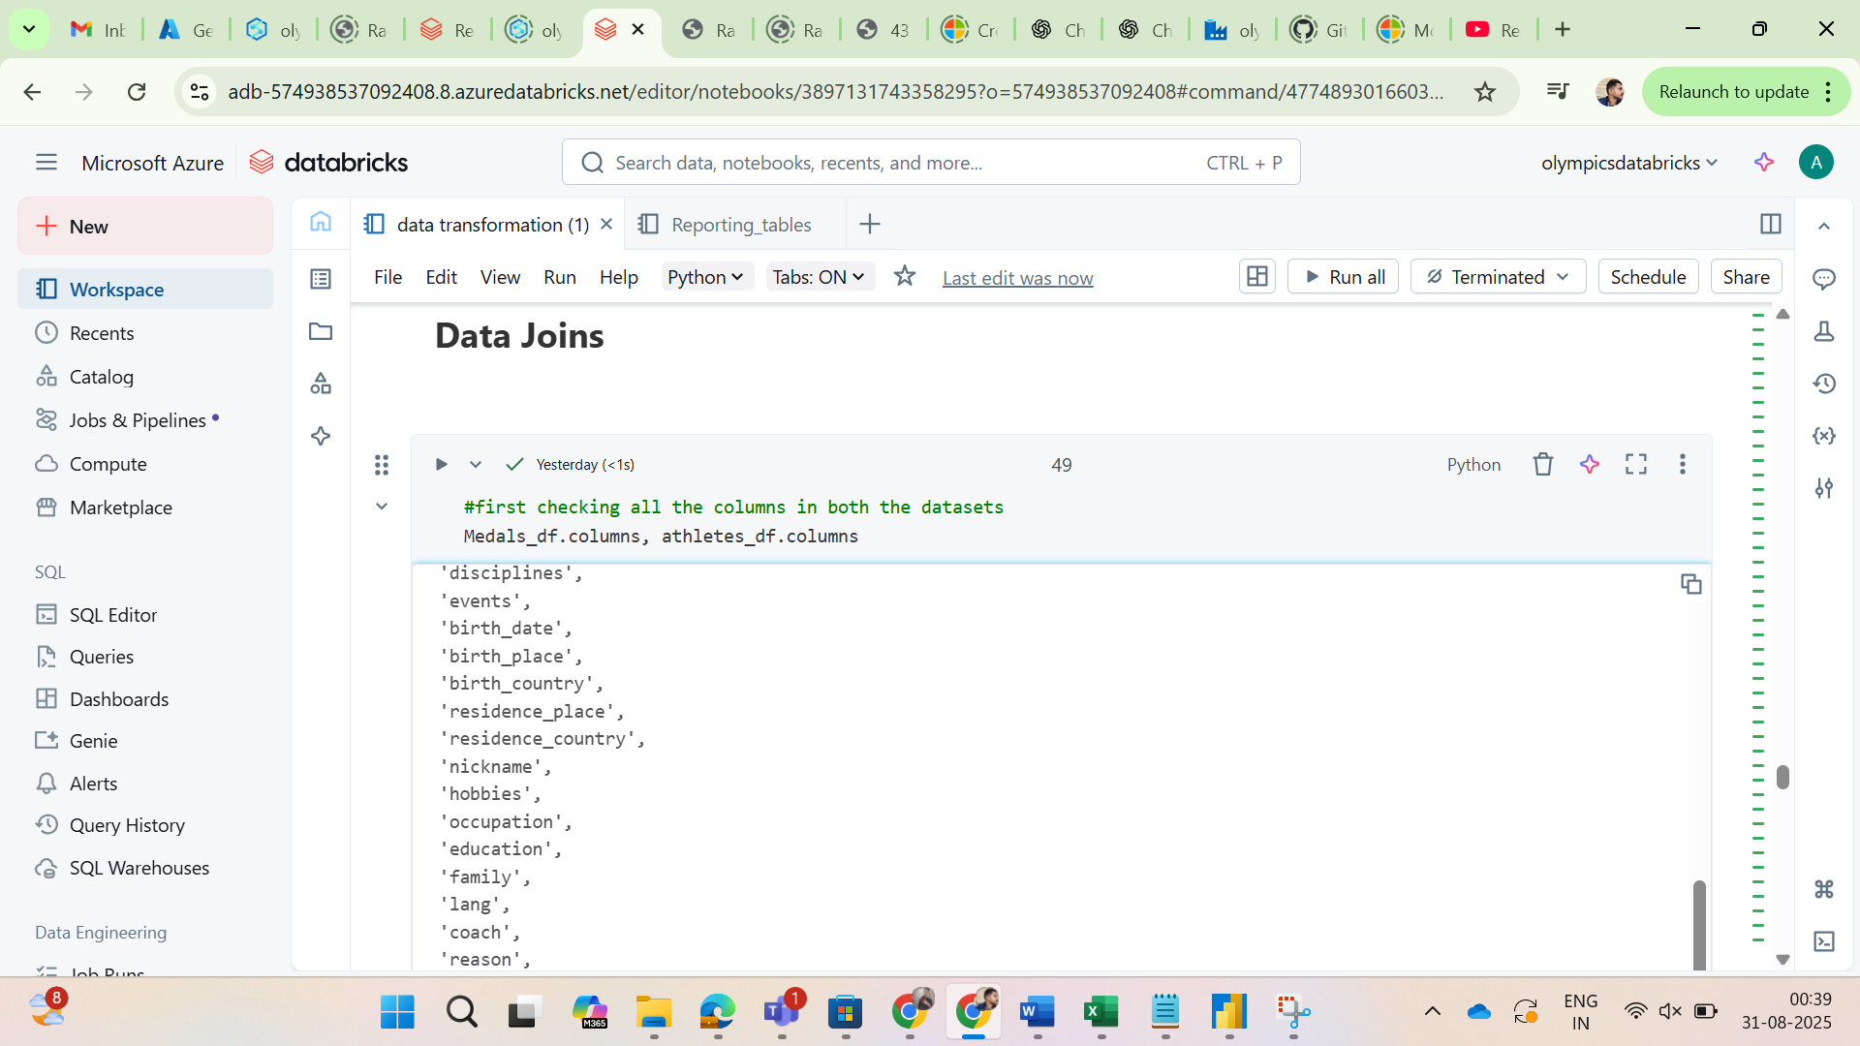

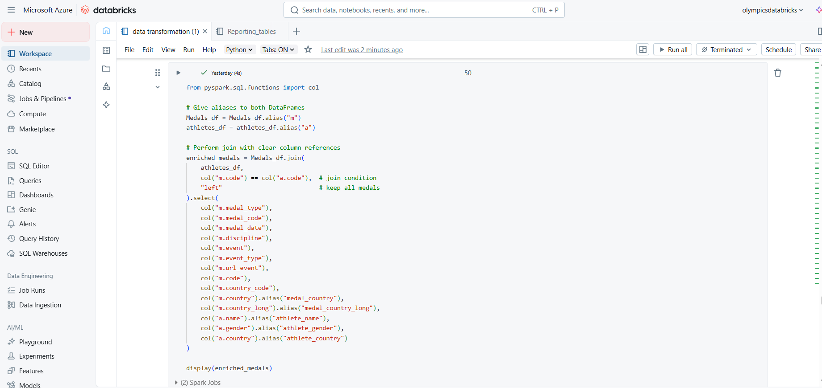

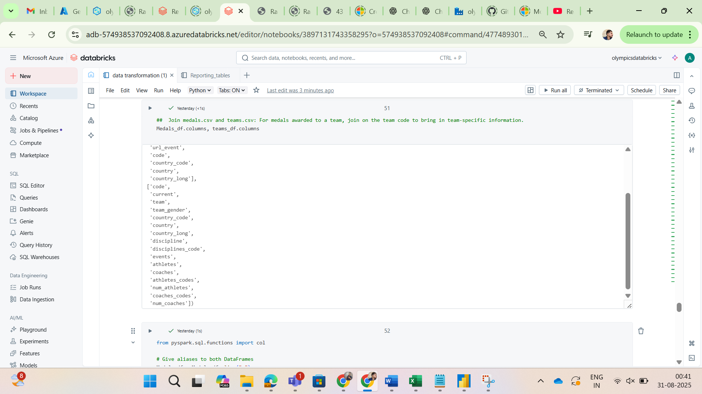

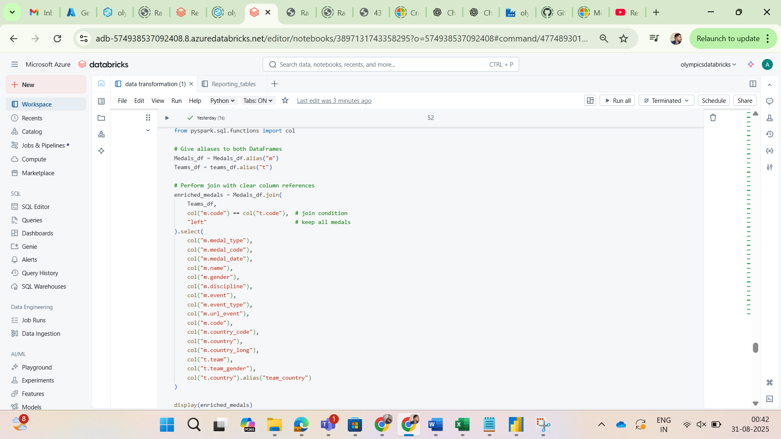

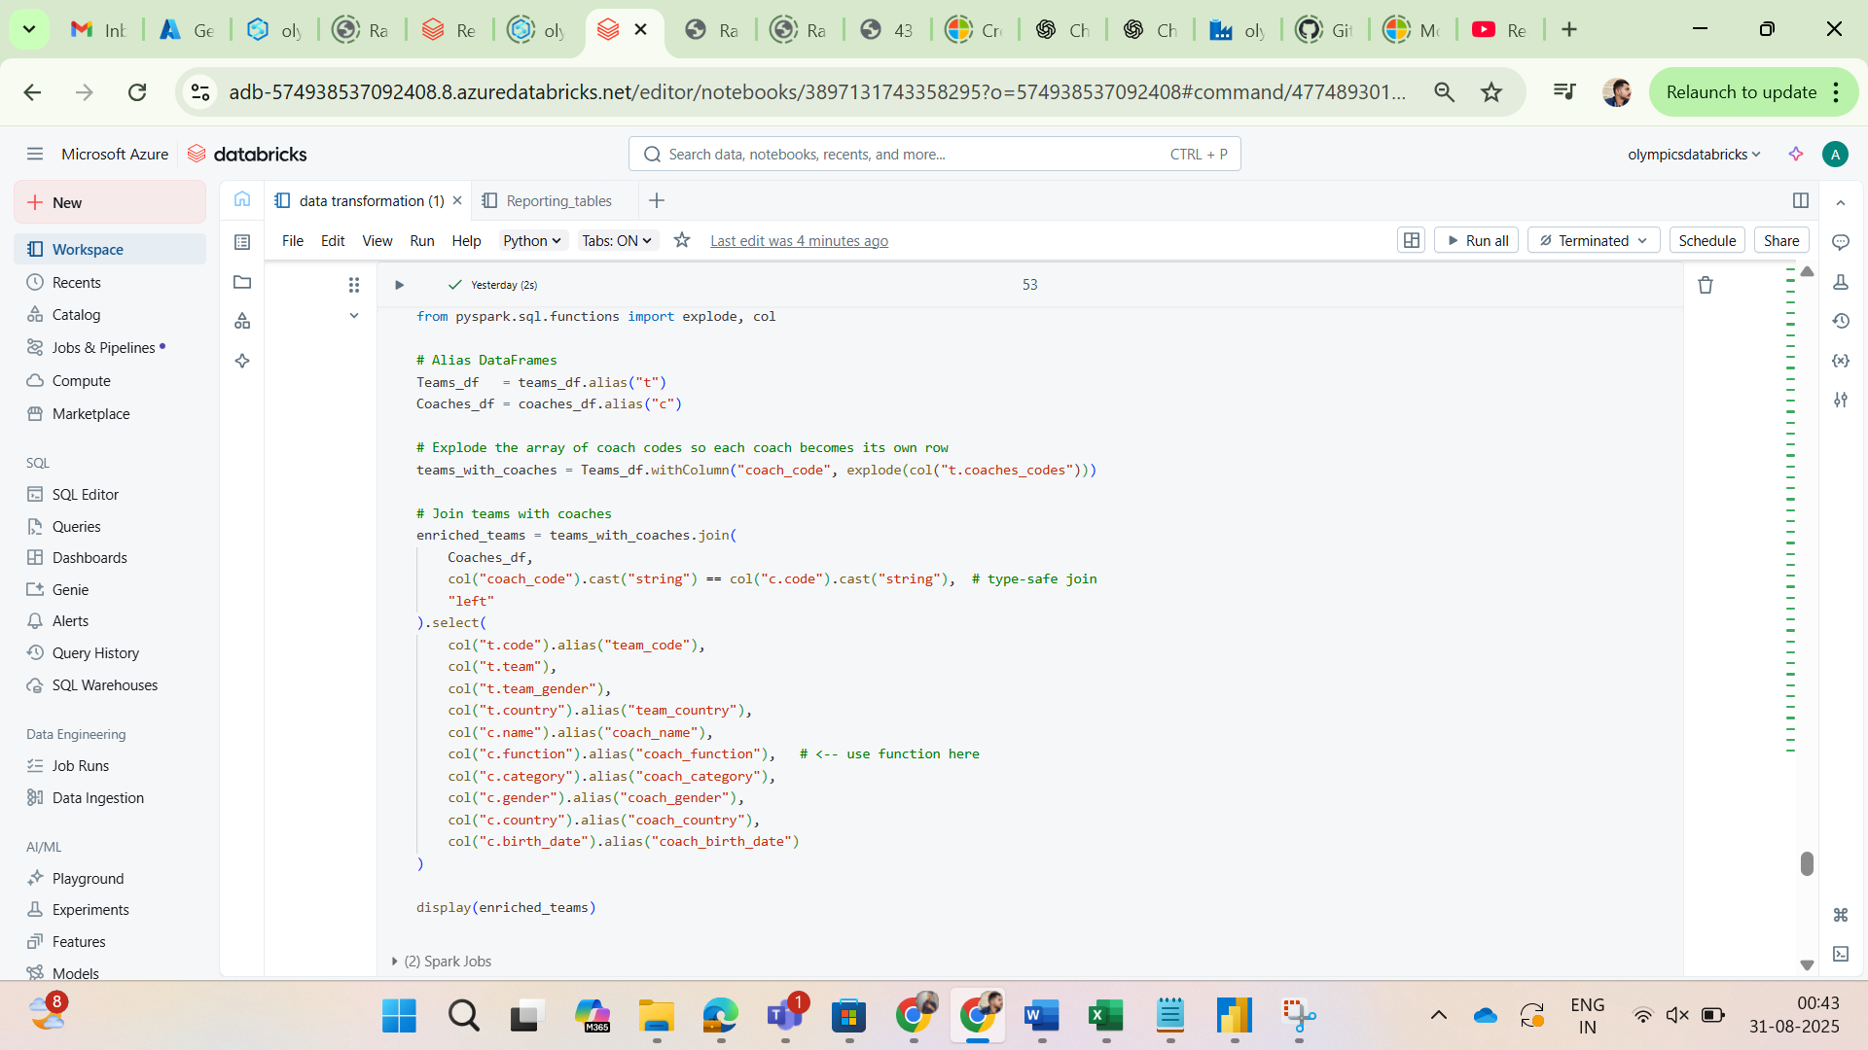

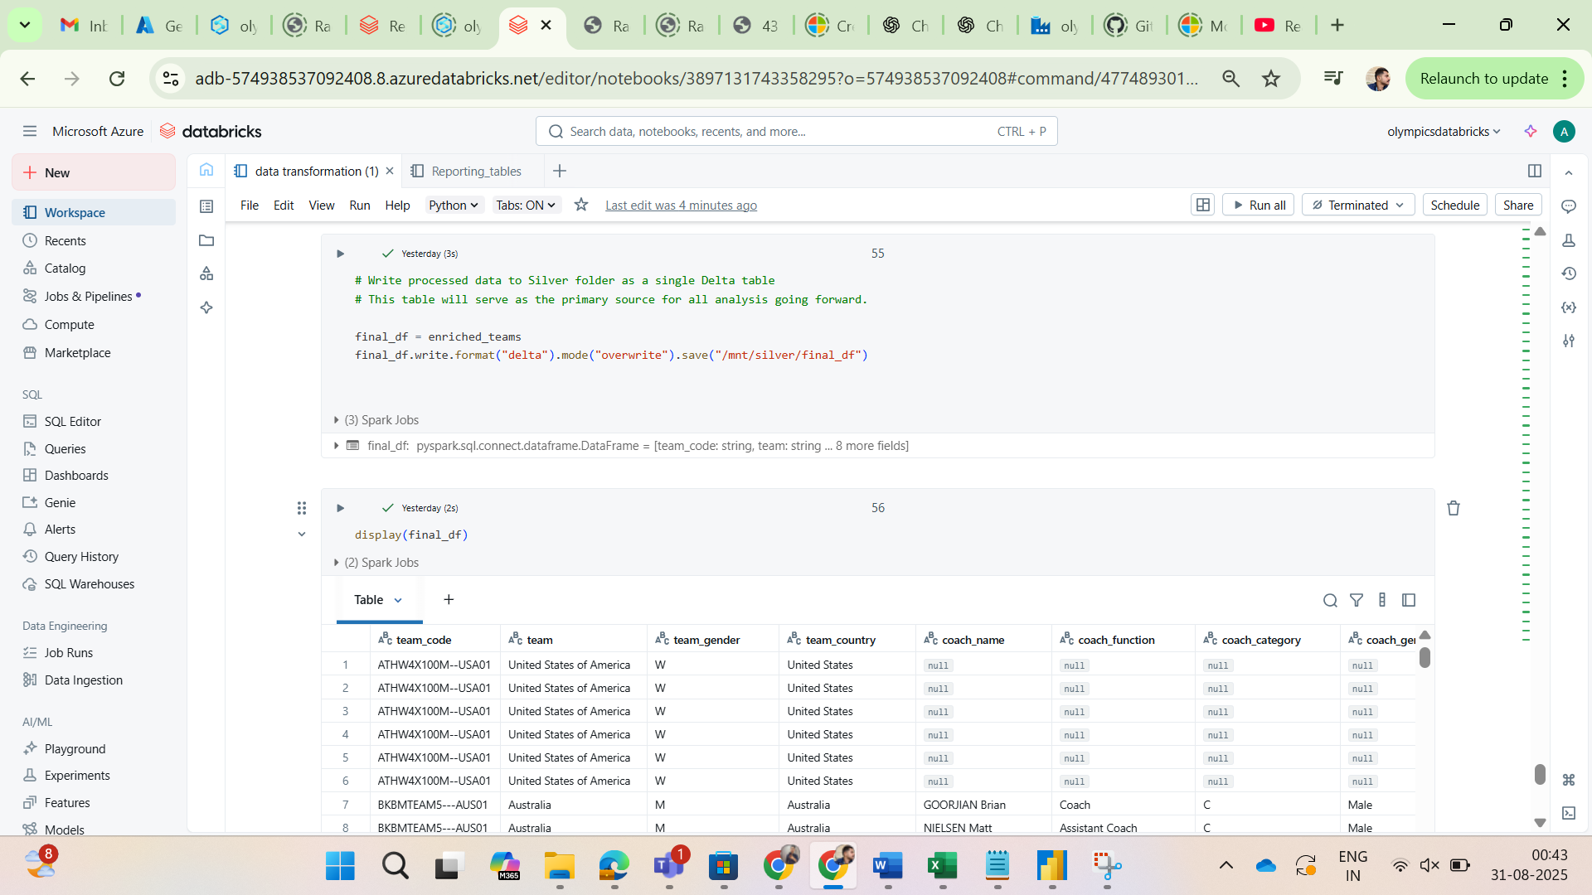

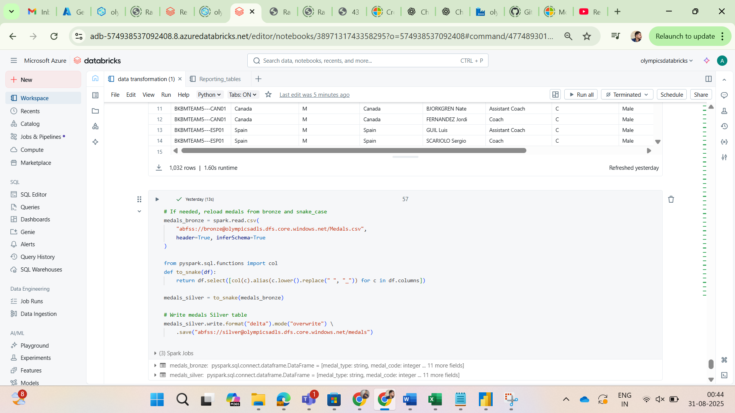

**Phase 3: Data Aggregation & Storage (Gold Layer)**

**1. Create Aggregated Data**

* Created a new Databricks notebook (e.g., reporting_tables.py).
* Loaded the cleaned data from the silver Delta table.
* Performed aggregations to generate a report-ready table, including the total number of Gold, Silver, and Bronze medals for each country.
* Stored this aggregated table as a new Delta table in the gold folder, optimized for quick querying and reporting.

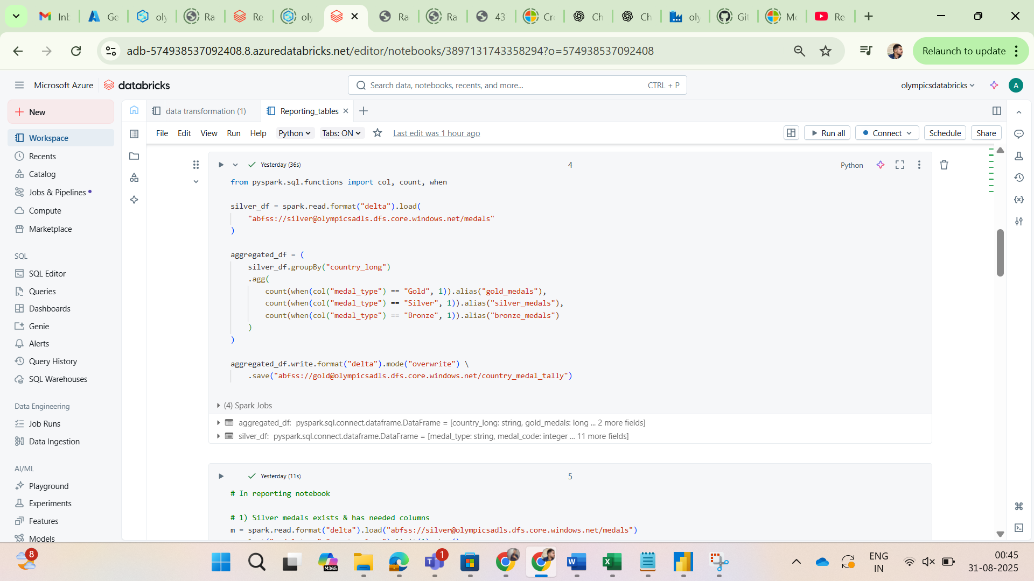

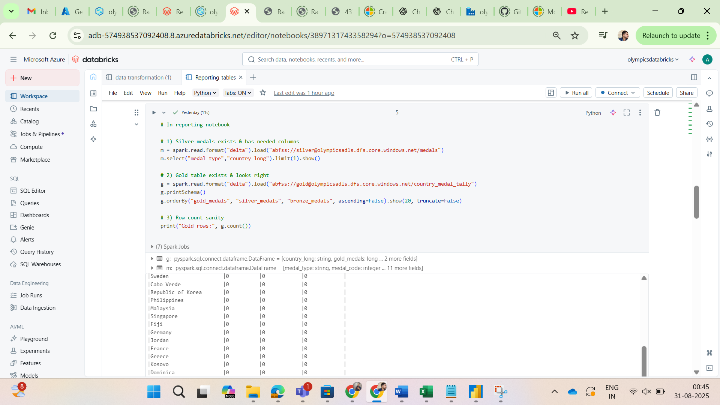

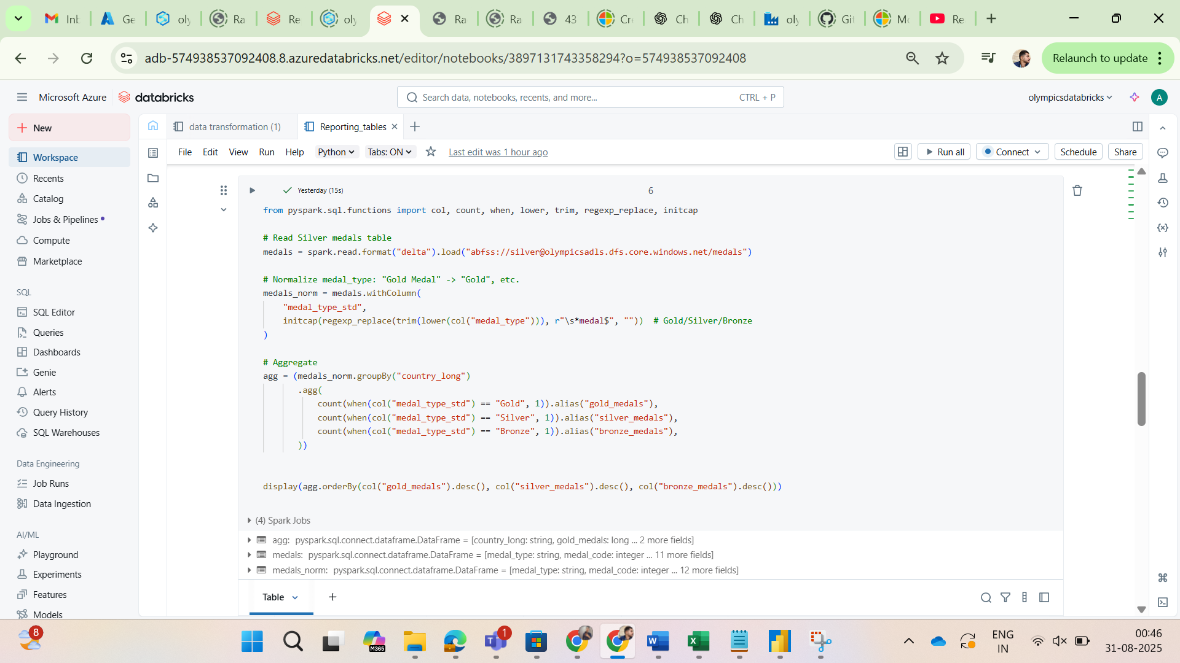

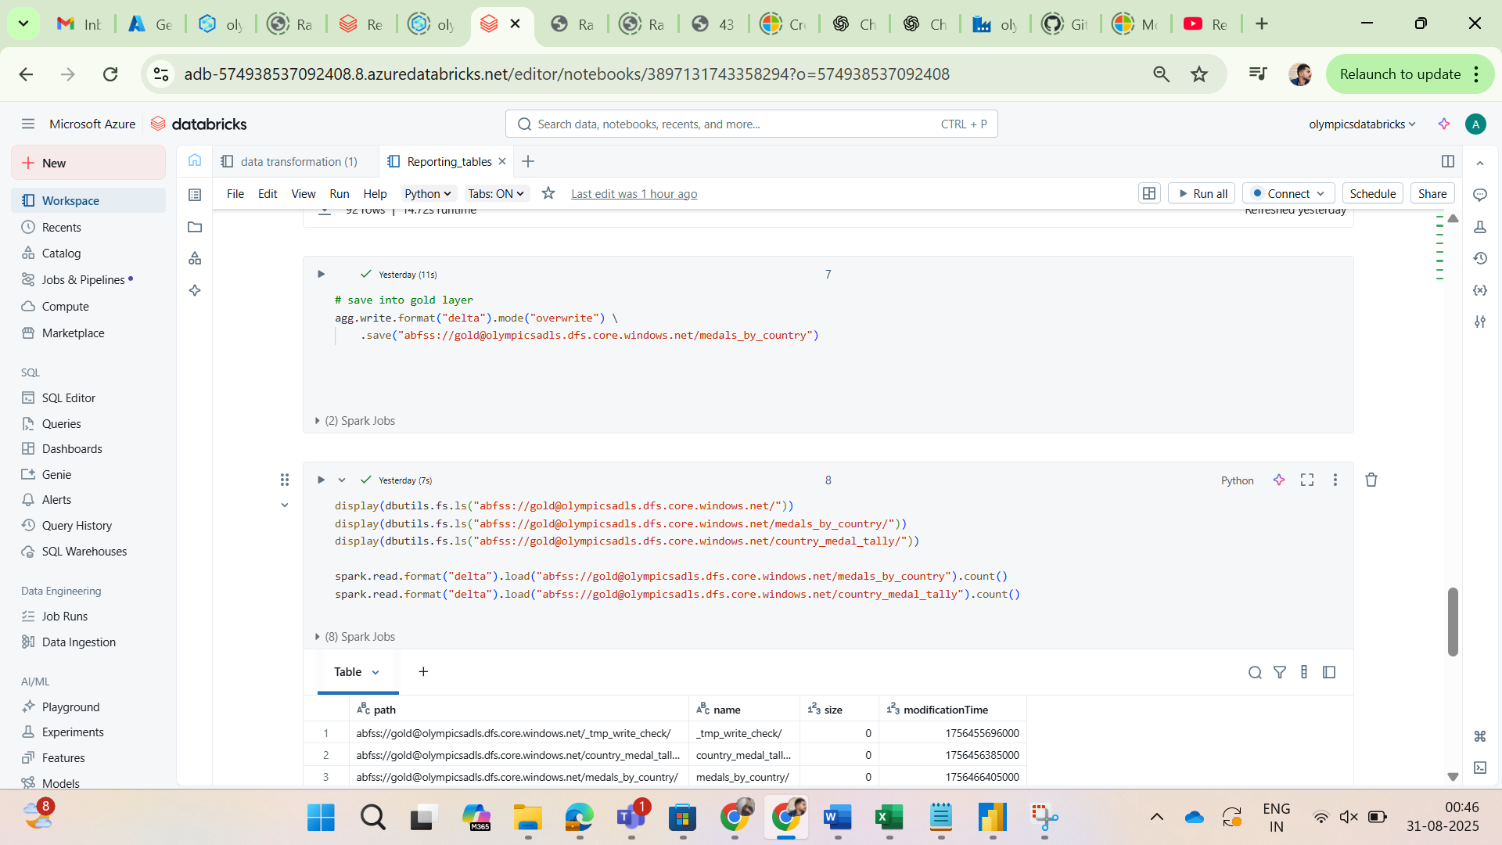

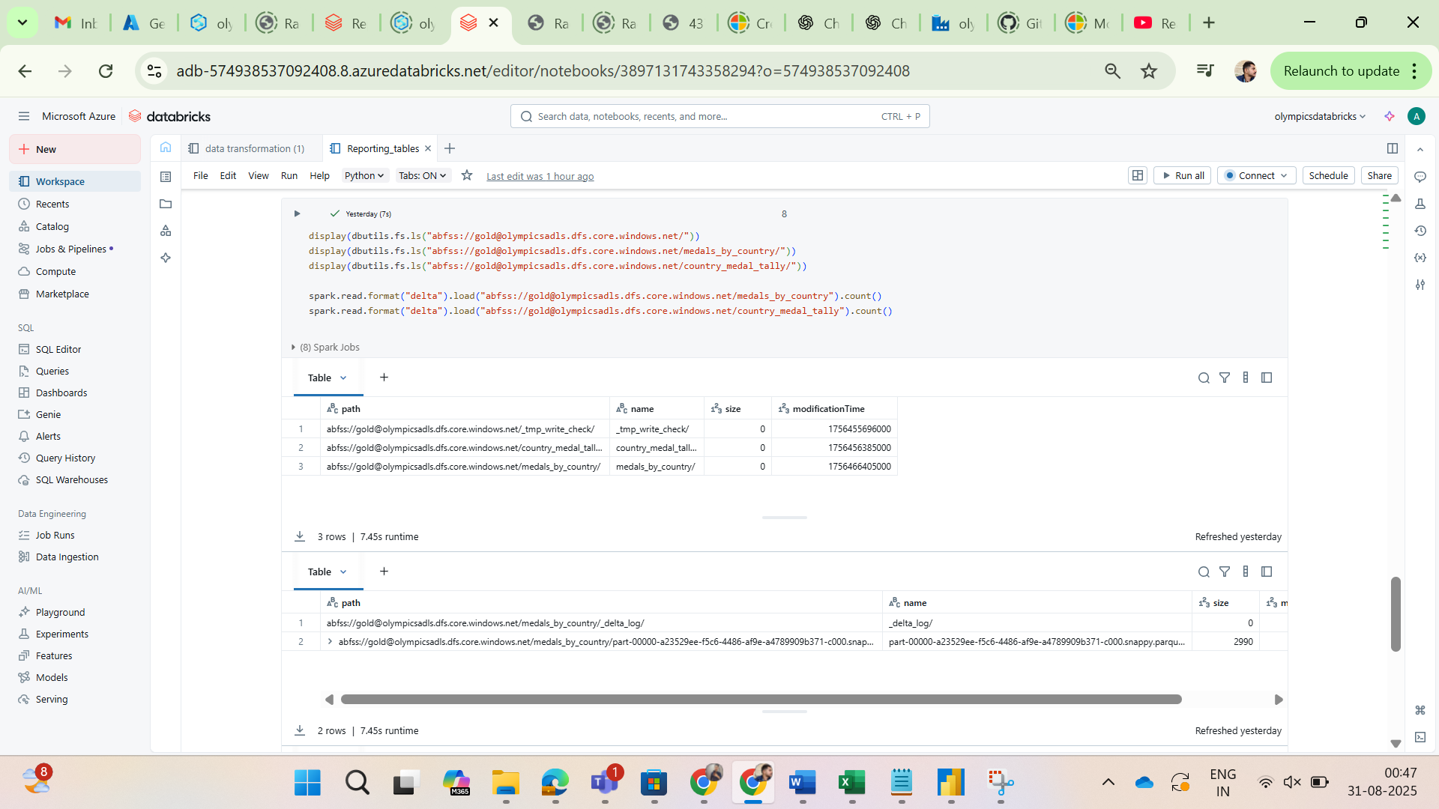

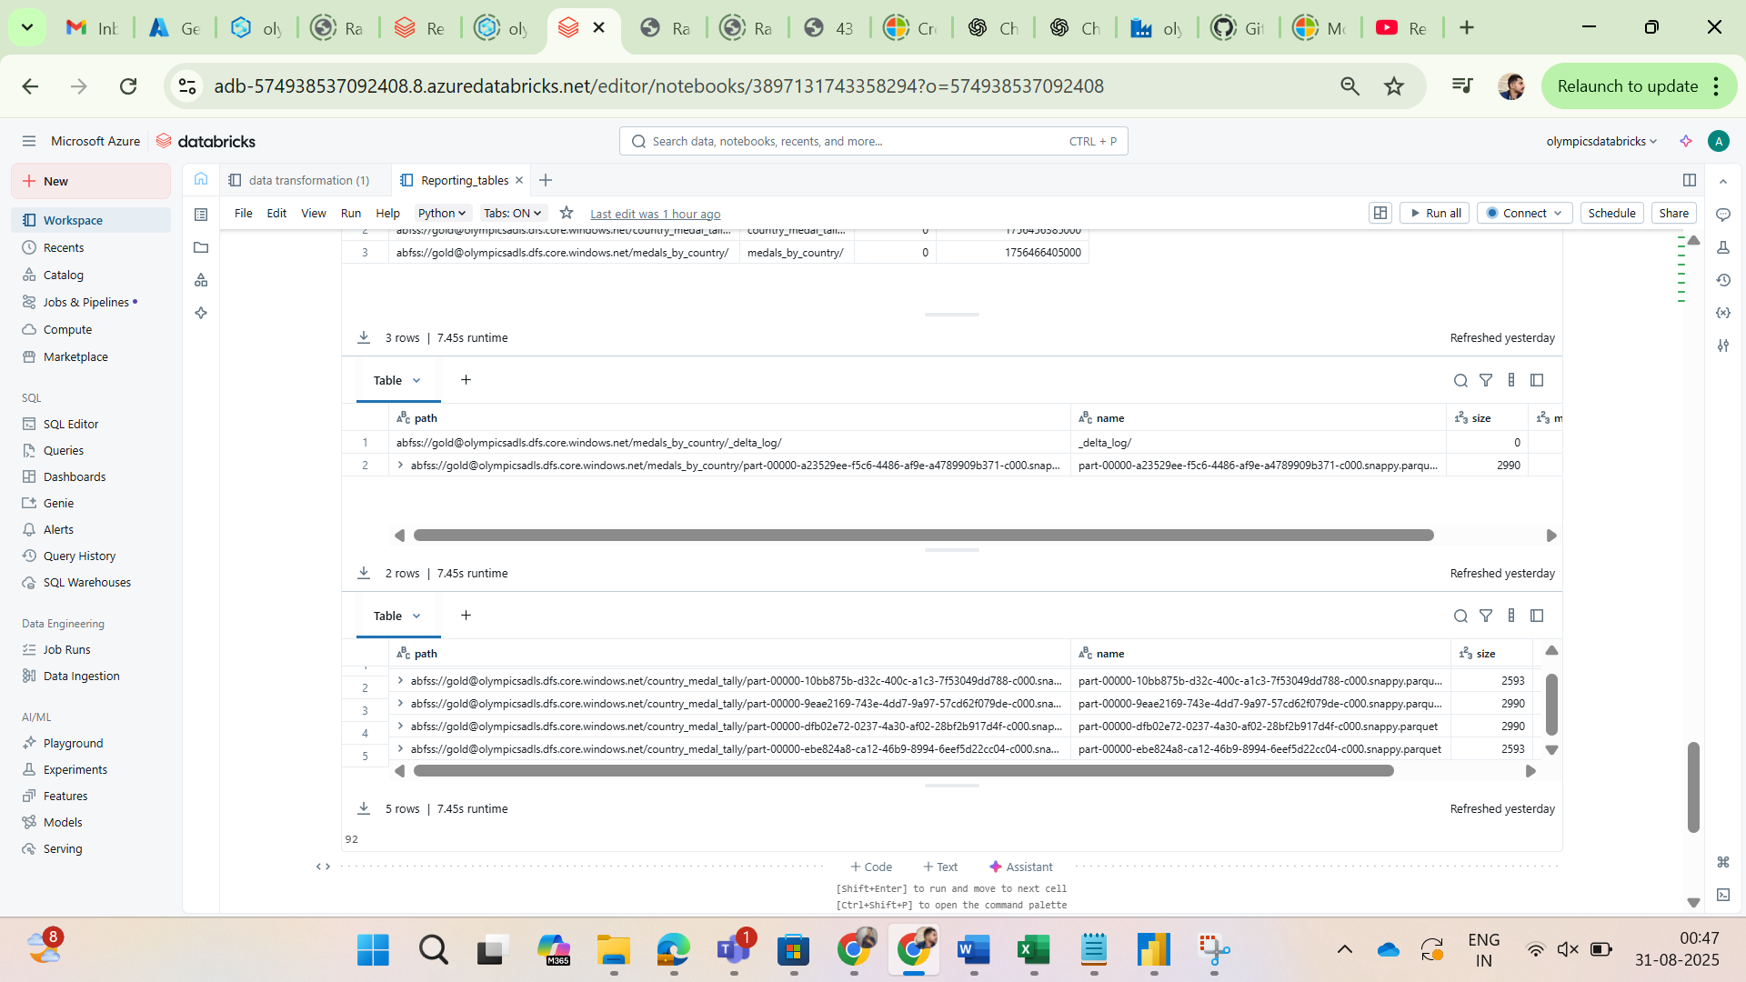

**Phase 4: Reporting & Visualization (Power BI)**

**1. Connect Power BI**

* Opened **Power BI Desktop** and connected it to the **Data Lake Storage Gen2**.
* Accessed the **gold Delta table** created in the previous step.

**2. Build a Dashboard**

* Built an interactive **dashboard** in Power BI using the aggregated gold-layer data.
* Created a simple yet insightful **dashboard** that included at least three different visualizations to tell a story about the Olympic data:
  + A **bar chart** showing the **top 10 countries** by total medal count.
  + A **donut chart** illustrating the distribution of medals (**Gold, Silver, Bronze**).
  + A **table** displaying the detailed medal count per country.

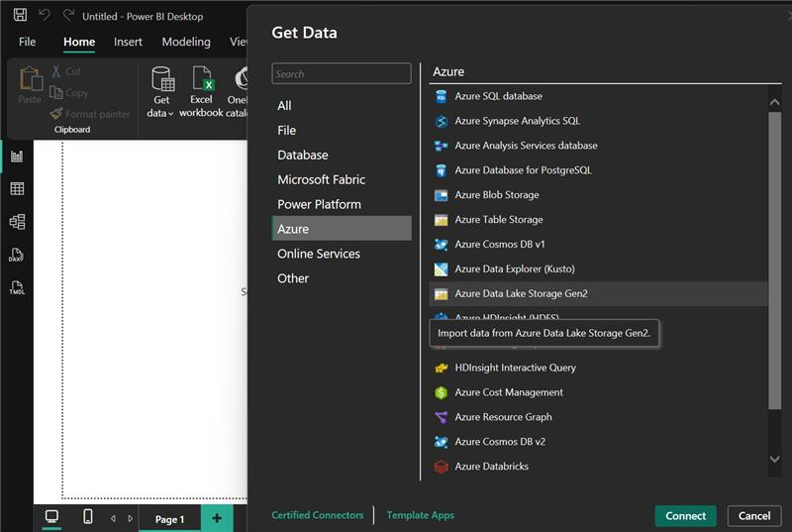

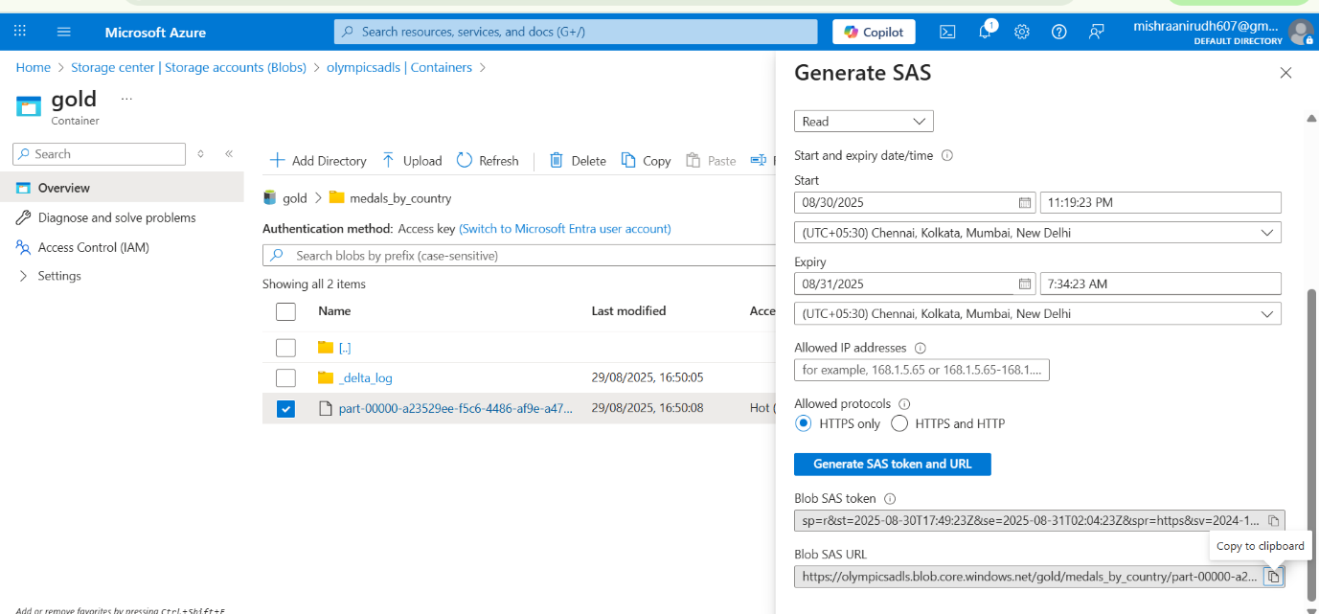

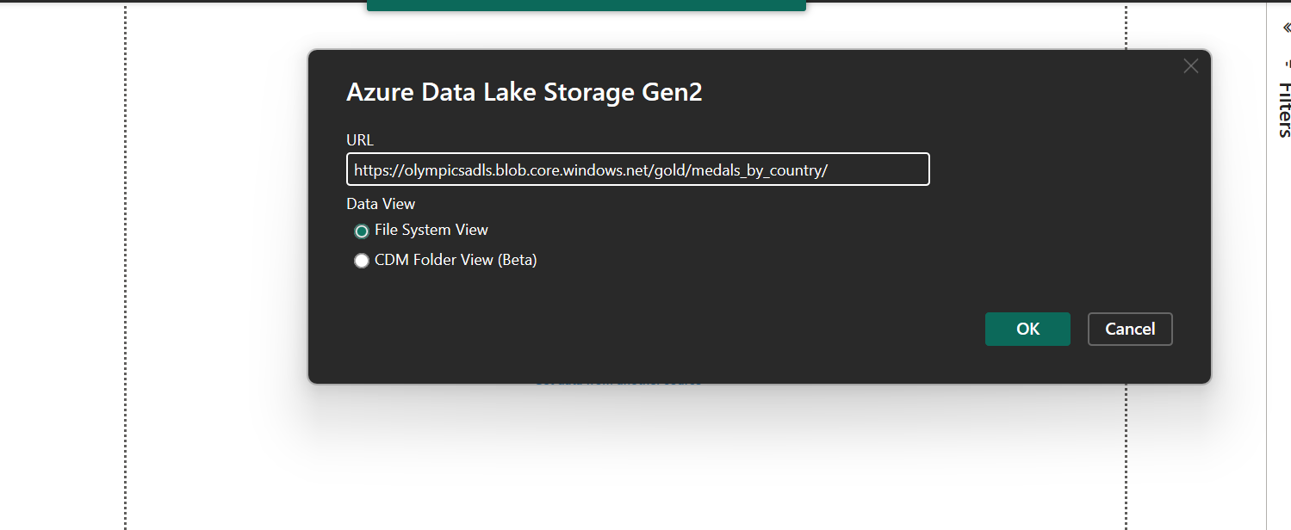

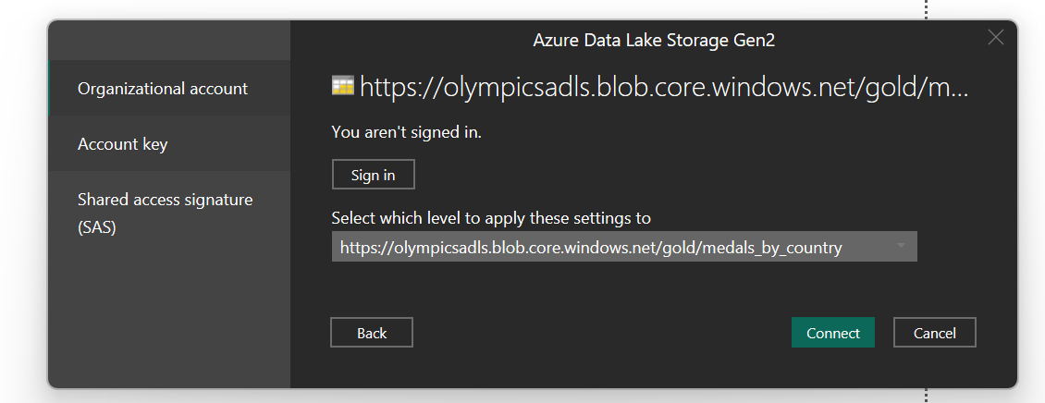

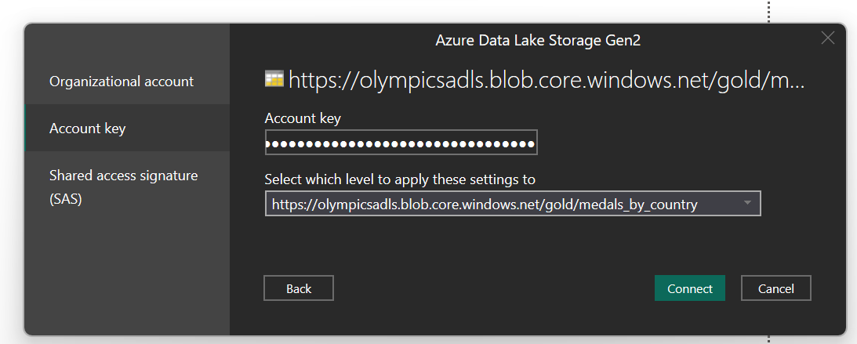

Once the connection was successfully established, the final **dashboard** was built with the following visualizations:

* A **bar chart** displaying the **top 10 countries** by total medal count.
* A **donut chart** showing the **distribution of medals** (Gold, Silver, Bronze).
* A **table** presenting the **medal count per country** in detail.



